Anxiety scale – example

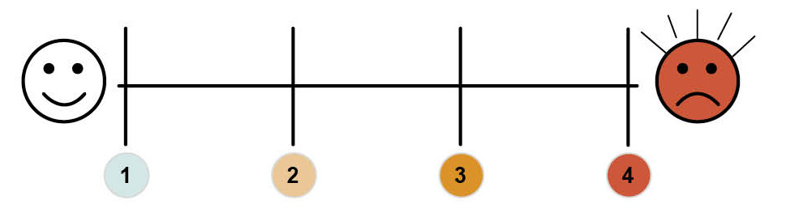

1 = Appears calm, relaxed. Able to engage in general conversation. Laughing, joking.
Happy to engage in activities. Relaxed body posture. Smiles.
2 = Asking questions but able to engage in two-way conversation. Predictability relieves anxiety. Can be distracted into activities/tasks. Able to sit down for periods of time. Some laughing/joking ‘How’s that car’.
3 = Asking lots of repetitive questions but able to focus on what you are saying. Predictability reduces anxiety. Pacing and difficulty focusing on tasks. Some hyperventilation. Frowning, whining voice.
4 = Asking lots of repetitive questions despite being given predictability, swearing/shouting.
Not able to focus on what you are saying. Not able to focus on tasks despite support. Pacing, walking up and down, unable to rest. Raised voice/crying. Hyperventilation, tense body movements, sweating.

Barriers to health screening checklist

Barriers to health screening checklist
 | Yes | No | Don’t know | Details
ENVIRONMENT Experiences anxiety about:
New environments, entering new buildings.
Meeting new people.
Medical equipment.
Waiting.
PAST EXPERIENCES
Previous negative experiences with medical appointments.
Associates health settings with pain.
Has experienced restraint in the past when undergoing medical procedures.
Had a lot of medical appointments/
treatment as a child.

Barriers to health screening checklist
 | Yes | No | Don’t know | Details
COMMUNICATION
Requires prior support to understand health appointment.
Requires visual information to back up process.
Concept of health screening too abstract.

SENSORY INTEGRATION DIFFICULTIES
SIGHT
Visual impairment diagnosis.
Under-sensitive e.g. objects appear dark, lose some of their features.
Over-sensitive e.g. distorted vision: objects and bright lights can appear to jump around.
Other:
SOUND
Hearing impairment diagnosis
Under-sensitive e.g. only hears sounds in one ear, may not acknowledge particular sounds.
Over-sensitive e.g. noise can be magnified and become distorted.

Barriers to health screening checklist
 | Yes | No | Don’t know | Details
TOUCH
Under-sensitive e.g. stands too close to others, bumps into people, has difficulty navigating rooms.
Over-sensitive e.g. touch can be painful and uncomfortable, does not like to be touched, dislikes
having anything on hands and feet.
Does not like others in their personal space.
Has become very anxious/ distressed at GP/medical appointments.
Has become challenging towards themselves during appointments.
Has become challenging towards others during appointments.
Becomes withdrawn during appointments.
Idiosyncrasies e.g. won’t leave the house if it is raining.
Other please state:

Barriers to health screening

Environment
 Unfamiliar clinical environments can cause anxiety.
 Entering new buildings and seeing medical staff can be difficult to cope with.
 Unfamiliarity with medical equipment and how it is used can increase anxiety levels further.

Past experiences
 Past negative experiences can have a major impact when accessing health settings.
 Some individuals may have experienced being restrained in the past when having medical interventions.
 Individuals may associate health settings with pain.
 An emergency medical intervention may leave the person fearful and anxious.

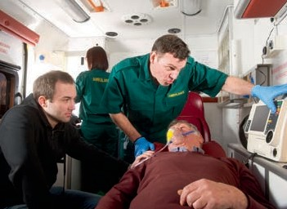

 The individual may not have been involved in medical decisions made about them previously and feel out of control.

Waiting times
 Waiting for long periods of time in a busy waiting room for appointments can increase anxiety.

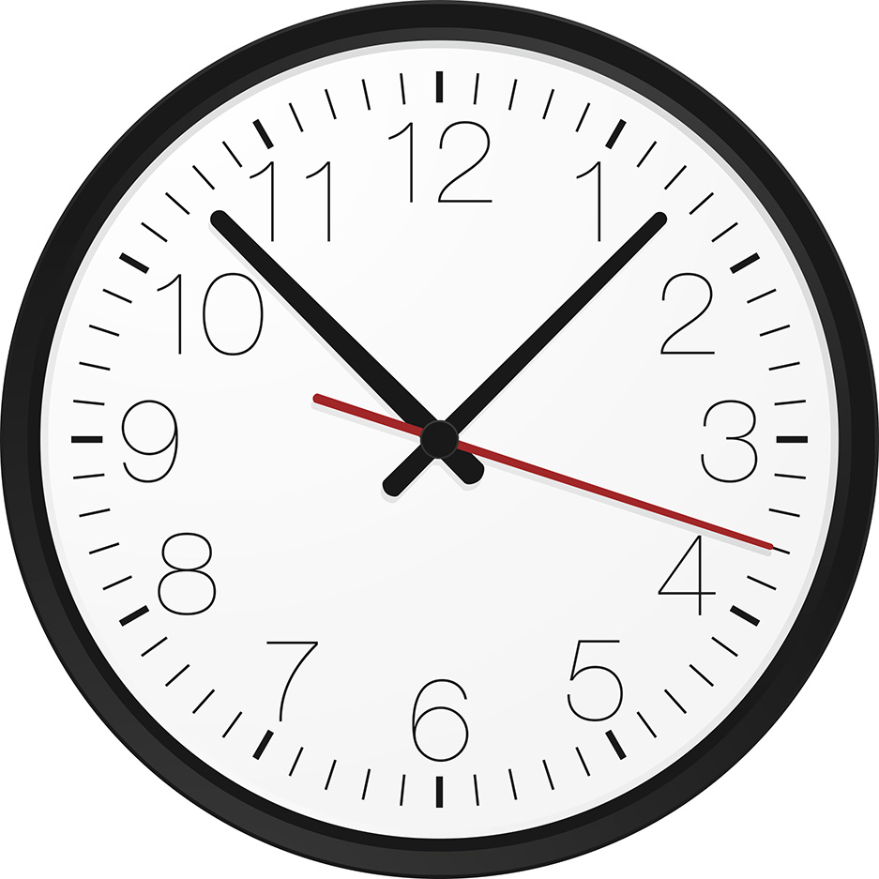

Communication
 Often people with a learning disability are not supported appropriately prior to an appointment.
 They may not be given information in a way that they understand and can process, regarding their health appointments.
 They may not understand why they are going to the GP for example, what will happen when they get there, who they are going to meet.
 Medical jargon can be overwhelming.

 Attempts at health screening without appropriate preparation and explanation exacerbate anxiety.
 Practitioners who may not understand the individual’s communication needs may concentrate on giving information to their carer. This may make the individual feel excluded and not in control of their personal information.

 For people with severe and profound learning disabilities, the whole concept of health screening may be too abstract for them to understand.

?

Support
 Being supported by a person they know well and trust can provide an individual with a degree of ‘safety’ in unfamiliar environments or situations. Without this, anxiety levels can be increased, creating significant barriers.

Sensory issues
 Many people with autistic spectrum disorder (ASD) have difficulty processing everyday sensory information such as sounds, sights and smells. This is called having sensory integration difficulties.
 People with ASD can become over-sensitive or under-sensitive in any or all of the seven senses: sight, sound, touch, taste, smell, balance and personal space.

Sight
 People who have over-sensitive sight for example, may have distorted vision;
objects and bright lights can appear to jump around.
 Imagine being in the building below if you have over-sensitive sight. How would that make you feel and behave?

 Under-sensitive sight can mean objects may appear quite dark or lose some of their features.

Sound
 If an individual has over-sensitive hearing, noise can be magnified and sounds become distorted and muddled.
 Busy hospitals and GP surgeries can be very overwhelming with many noises and sounds from all directions. This can cause sensory overload.
 If the individual’s hearing is under-sensitive, they may not acknowledge particular sounds, or they may only hear sounds in one ear and/or partially in the other.

Touch
 Under-sensitive touch means an individual may need to hold others tightly before there is a sensation of having applied pressure. They may have a high pain threshold; they may self-harm.
 Over-sensitive touch may mean touch can be painful and uncomfortable. The individual may not like to be touched; they may dislike having anything on their hands and feet.

Personal space
 For some individuals having other people in their personal space can be traumatic. This can make it very difficult for practitioners to provide health screening.
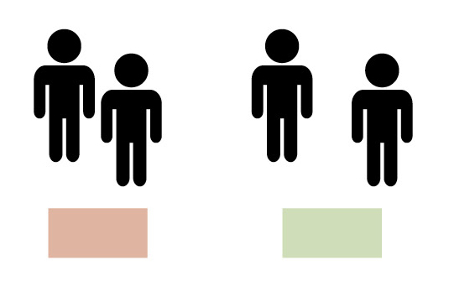

not ok ok

 GP surgeries and hospitals can, therefore, cause sensory overload due to noise, crowds, lights, sounds etc. Additional sensory impairment such as hearing and visual loss may also increase anxiety and confusion in unfamiliar environments.
 People with sensory integration difficulties who struggle to deal with all this information are likely to become stressed or anxious, possibly feel physical pain or become challenging to themselves or others.

Behaviour
If an individual experiences any one or a combination of the barriers mentioned it could lead to:

 refusal of future appointments
 becoming distressed and anxious during an appointment
 increasing negative experiences for the individual associated with medical appointments
 challenging behaviour towards the environment, themselves or others, thus exacerbating their negative experience and relationship with the health setting.

Blood test desensitisation programme monitoring sheet

NAME:

D.O.B:

Date & time | Step number | How did they respond  – please give details | Staff name and signature

Please complete each time you support the individual with their programme.

IT IS ESSENTIAL THAT YOU DO NOT MOVE ON TO THE NEXT STEP UNLESS IT HAS BEEN AGREED AT THE DESENSITISATION CLINIC.

The steps …….. needs to achieve
a blood test

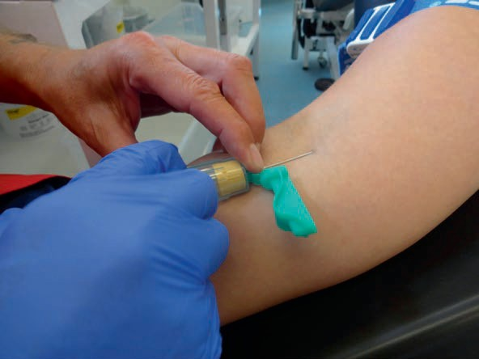

STEP ONE

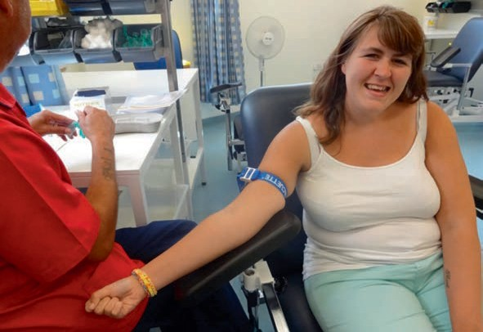

..….. to wear the tourniquet daily.
Start by wearing it for 1 minute then increase
for up to 5 minutes.

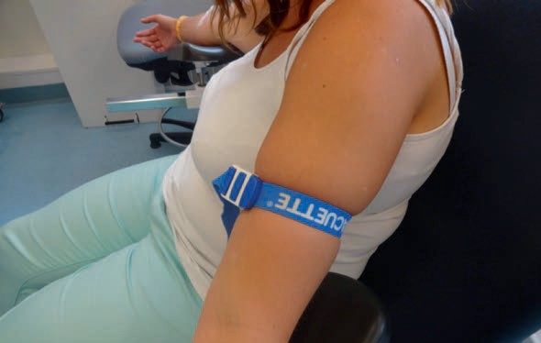

STEP TWO

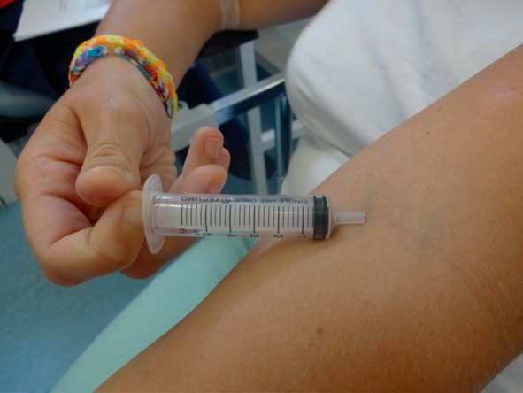

……. to be given a syringe to
hold and familiarise himself with each day for several minutes.

STEP THREE

……. to wear the tourniquet and hold the syringe at the same time for
up to a maximum of 5 minutes.

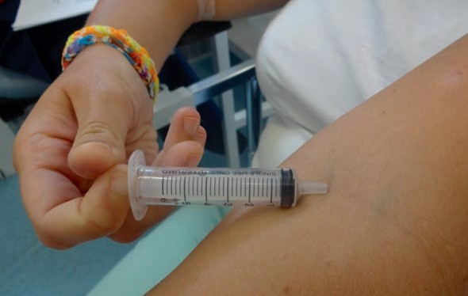

STEP FOUR

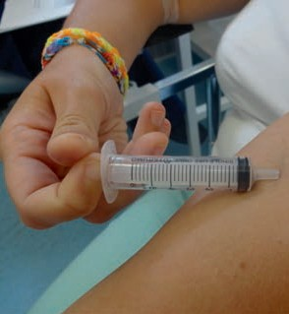
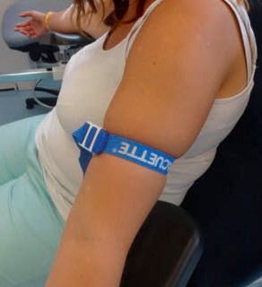

…….. to wear the tourniquet and hold the syringe. Staff to use an alcohol
wipe on the inside of the elbow.

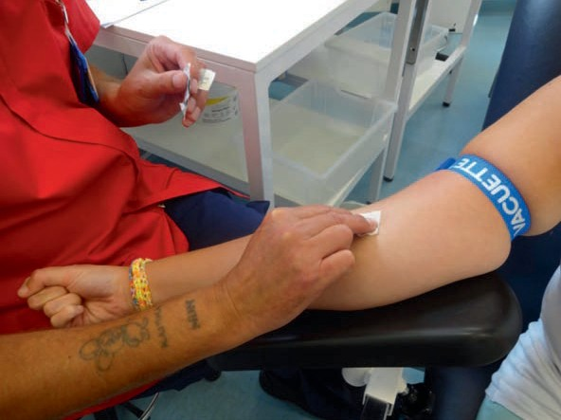

STEP FIVE

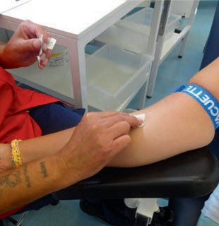
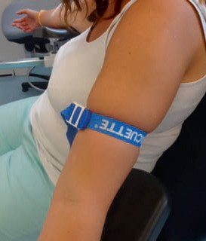

……. to wear the tourniquet, staff to apply alcohol wipe. Staff to hold the syringe, and place it where the elbow has been cleaned.

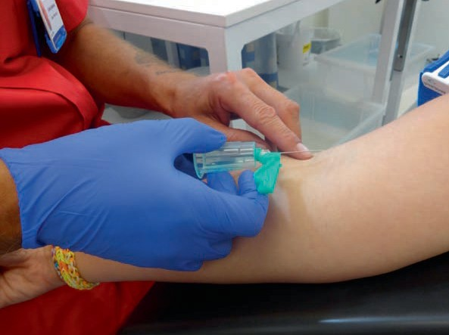

STEP SIX

NURSE ONLY INTERVENTION

…….. to wear the tourniquet, alcohol wipe to be applied and nurse to place syringe with needle attached.

STEP SEVEN

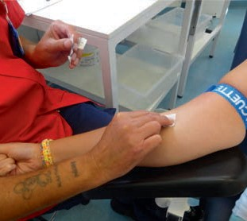
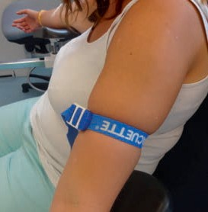

NURSE ONLY INTERVENTION

……. to wear the tourniquet, alcohol wipe to be applied. NURSE to place syringe with needle attached to the inside of the elbow. …….. to be shown separate syringe
with fake blood in it.

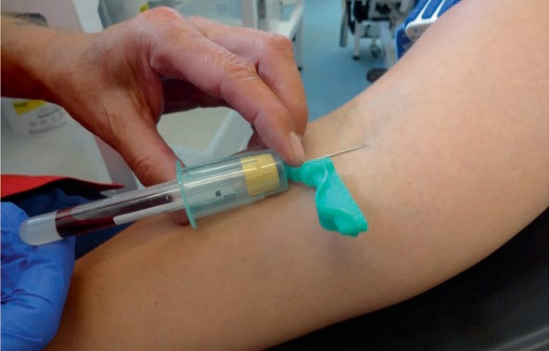

STEP EIGHT

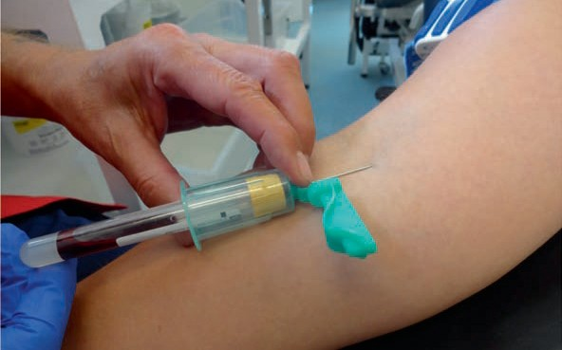

NURSE ONLY INTERVENTION

…….. to follow step seven. …….. to
be shown a syringe and needle with
blood in it. Cotton wool ball to be
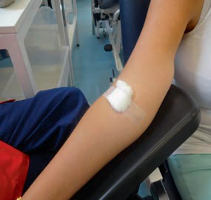
placed on the inside of the elbow and pressure applied for several seconds.

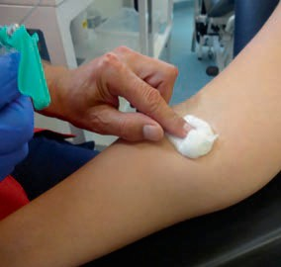

STEP NINE

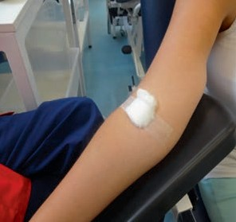
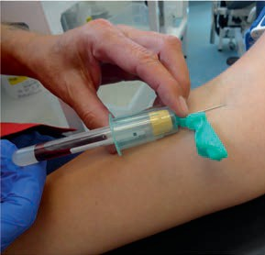

NURSE ONLY INTERVENTION

……… to follow step seven and eight. Cotton wool ball to be placed on the inside of the elbow and pressure applied. Small round plaster to be applied to the area.

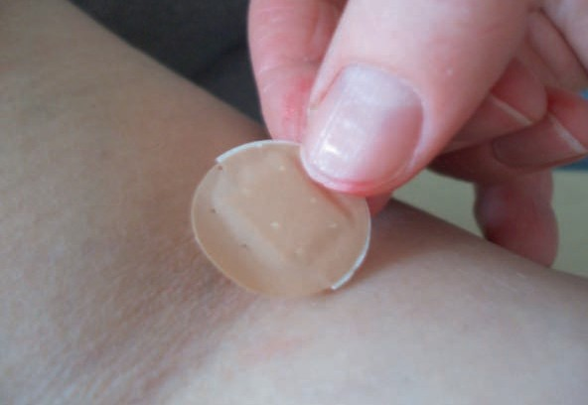

STEP NINE

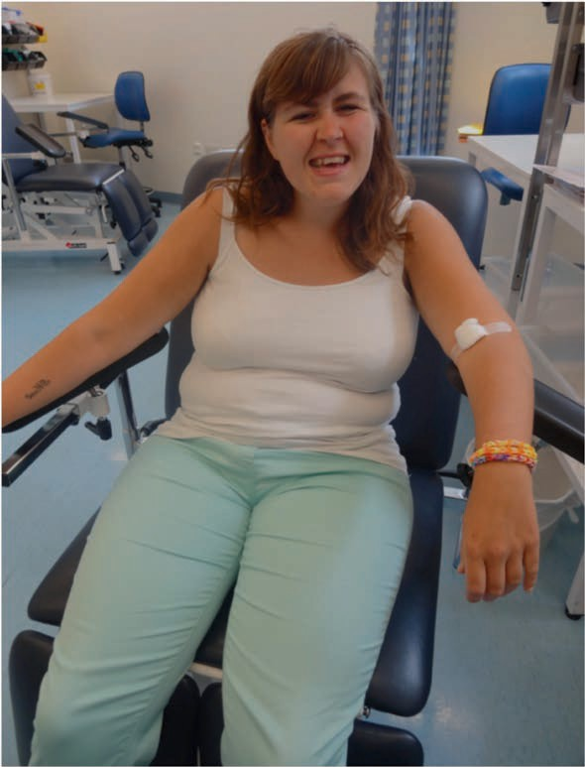

WELL DONE …..!!!

We will look at this with
you again tomorrow.

Steps to taking a temperature

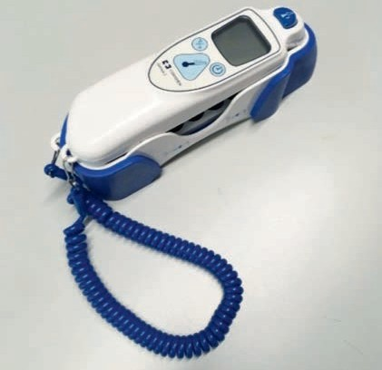

STEP ONE
Show the individual the
tympanic thermometer.

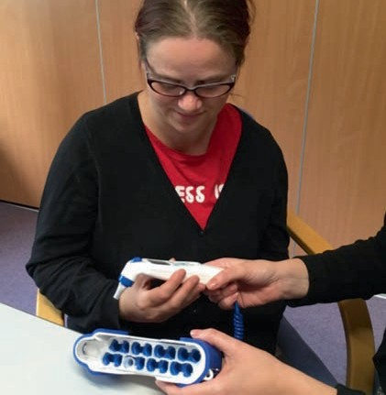

STEP TWO
Let the individual hold the thermometer and explain what it is for. For example, ‘I am going to put this into your ear to check if you are too hot or too cold’.

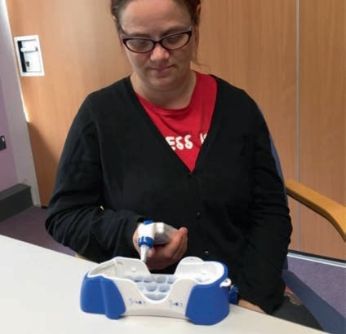

STEP THREE
Ask individual to put thermometer to their ear. If needed put your hand over the individual’s hand and guide it so that they put it into
their ear.

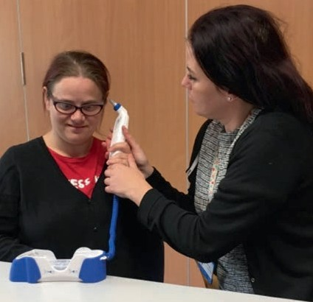

STEP FOUR
When the thermometer is in the individual’s ear explain that you are going to press the button and that it will make a beeping noise when the temperature has been taken.

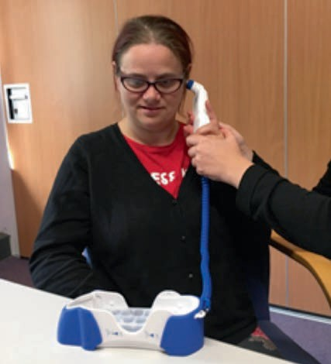

Repeat steps one, two and three however many times are necessary.

Steps taken to
listen to the heart

STEP ONE
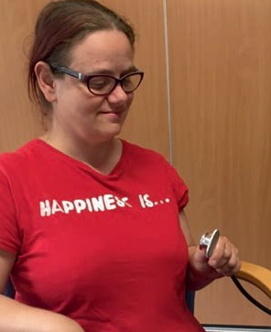
Show the individual the stethoscope so that they can familiarise themselves with it.

STEP TWO
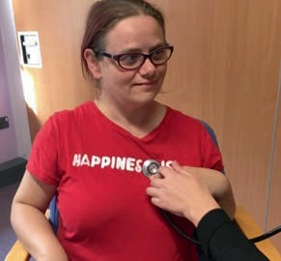
Ask the individual to put
the stethoscope to where
they think their heart is.

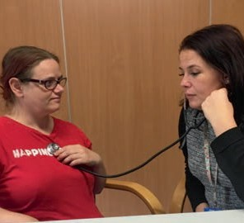

STEP THREE
The nurse listens to the
individual’s heartbeat.

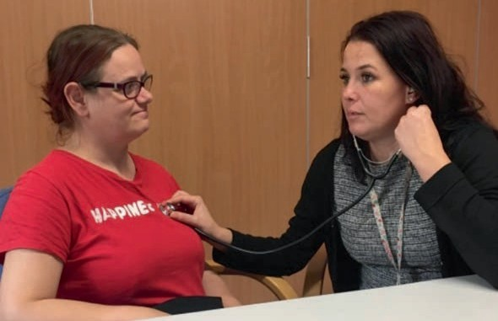

Desensitisation screening tool

NAME: D.O.B: NHS NO:
Health screening required:
General health screening (BP, height, weight, pulse, temp, heart rate) □
Blood test □
Electrocardiogram (ECG) □
Flu vaccination □
Blood glucose (BG) □

Other health screening, please state:

1. When did the individual last have health screening with their GP/practice nurse?

2. Has the GP/psychiatrist highlighted a clinical need for desensitisation work?
Please state:

3. Have there been difficulties accessing health screening in the past? (please circle)

Sensory Environment Communication
Past history/experiences

Anxiety levels/behaviour

Difficulty meeting new people/accessing new environments

Other

[Complete barriers to health screening checklist]

Clinical priority: (Please identify priority and tick relevant box)
HIGH: □

Individual is requiring health screening urgently due to a clinical need e.g. blood test, ECG.
MEDIUM: □

Individual requires health screening as part of the directed enhanced services/annual health check (Cardiff health check).
LOW: □

Individual has no immediate health screening need but may require screening in the future and requires preparation.

Desensitisation screening tool
Have any areas of risk been identified? (Complete a risk assessment.) Please state:

Does the individual consent to the health screening? Is a capacity assessment required? Please give details:

Does the individual require an onward referral/signposting e.g. speech and language therapy. Please state:

Does the individual require: (Please tick relevant boxes)
One-to-one input: □ 
Desensitisation clinic: □ 
Do the individual and their carers require education around the process? □ 

Desensitisation programme

Purpose of programme
 To help reduce anxieties around having an ECG. This program aims to familiarise an individual with the process of having an ECG and enable them to successfully undergo this procedure providing necessary health screening.
 The individual should be supported through these steps gradually, at a pace that they are comfortable with. Introduce one step at a time and staff should support the individual to complete this on a daily basis. Only once they have achieved a step completely and are comfortable with the process of that step should they be supported to move forward in the programme. If the individual is moved too quickly through the programme this can increase their anxiety.
 During the ECG procedure an ECG sticker will be placed on each wrist, and their ankles (please see diagram on the next page).
 If the individual has any chest hair this will need to be removed to prevent any hair being ripped out when the stickers are removed. As part of this programme the individual should be supported to have their chest hair shaved in the areas where the ECG stickers will be placed (please refer to diagram on p35). This should be completed regularly throughout the desensitisation programme to familiarise the individual with this and therefore reduce their anxiety.
 Towards the end stages of the programme the individual will need to take off their upper body clothing. It is imperative they are supported by an appropriate and familiar member of staff during this stage.

Requirements of an ECG
 When an individual has an ECG they will be required to remove their upper body clothing. This is so the ECG stickers can be placed in the correct location on the body to ensure accurate readings.
 It is important to be mindful of the individual’s privacy and dignity at all times. The staff member/carer implementing the programme and supporting with the appointment will need to be a person the individual trusts and feels comfortable and at ease with.
 For some individuals their anxiety may be increased by having to remove their clothes. It will therefore be important to support them to become familiar with this as part of the programme. Steps 3-6 may need increased time and frequency to help with familiarisation and to help reduce anxiety.
 Females can be supported throughout the programme whilst wearing their bra. However, as the time approaches when they are ready to have their appointment, steps 3-6 will need to be completed without their bra. Respect and dignity must be maintained at all times.

Mental Capacity
 When supporting the individual with this programme their capacity to consent should be considered in line with the Mental Capacity Act (2005). If an individual is unable to consent the implementation of this programme will need to be considered with the best interests process in mind. Discussions with all relevant medical professionals and carers/family are essential.
 Please refer to the mental capacity section (Session 11) in the pack for further information.

Communication
 It is essential that the person supporting the individual communicates in a calm, positive manner using a gentle and reassuring tone of voice when supporting them throughout this process, allowing the individual to dictate the pace of each step. Under no circumstances should the individual be pressurised into completing any stage of the programme that they do not want to do; this would only increase their anxiety and jeopardise the success of this process.
 To support the individual to recognise the duration of each step, please use an auditory/visual timer to count down from the start of the step to the end.
 The person supporting the individual should ensure that this programme is adhered to; continuity is essential to ensure that the program is successful.

Positive reinforcement
 Throughout each session the use of verbal praise should be used to reinforce the individual’s successes. If an individual has an item or belonging that specifically reduces their anxiety make sure that this is available throughout the session.
 After each session the individual should be supported to engage in an activity of their choice that they enjoy. This could be an outing, activity or a particular food and drink they enjoy.

ECG desensitisation programme

Step 1
Individual to lie on their back on their bed fully clothed. Start with the individual doing this for one minute and gradually increase the time to five minutes.

Step 2
Staff to support the individual to hold the ECG stickers and wires. hand over hand, familiarising them with the feel of the ECG stickers and wires. This should be done for a couple of minutes two or three times daily.

Step 3
Individual to lay on their back with upper body clothing removed (females should continue to wear their bra until last stages). Start with individual doing this for one minute gradually increasing the time to five minutes.

Step 4
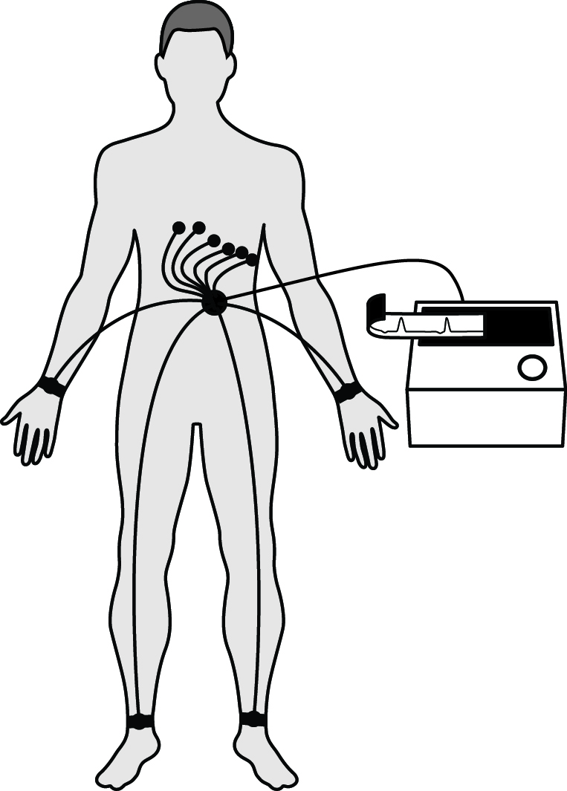
While the individual is lying on their bed with upper body clothing removed, staff should support the individual to hold the ECG stickers and wires hand over hand for a couple of minutes.

Step 5
Individual to lie on their bed with upper body clothing removed.

Place ECG stickers and wires on their body as demonstrated in diagram. Ensure the individual’s dignity is respectfully maintained at all times. If necessary for female individuals, stickers can be placed near to the location rather than the exact location to reduce unnecessary physical touch.

Step 6
Individual to lie on bed with upper body clothing removed. Staff to attach ECG stickers and wires to their skin as demonstrated in diagram. Remove ECG stickers and wires immediately after attaching them to the skin. The individual needs to become familiar with the sensation of both the stickers on their skin and the feeling of the stickers being removed. The time the individual wears the stickers on their
skin should gradually be increased to a total of five minutes. NOTE: if the individual has hair on their chest this should be shaved to prevent any hairs been ripped out when the stickers are taken off.

Step 7
The individual needs to visit their GP surgery and be supported to go into the room in which they will have the ECG procedure to familiarise themselves with the environment. No ECG equipment should be in the room at this time if possible.

Step 8
Individual to visit ECG room with nurse present.

Step 9
Individual to visit ECG room with ECG equipment present.

Step 10
Individual to visit ECG room and lie on clinic bed. Start with doing this for one minute and gradually increase to five minutes.

Step 11
Individual to lie on clinic bed with upper body clothing removed. Gradually increase the time on the clinic bed up to five minutes.

Step 12
Individual to lie on clinic bed with ECG stickers and wires attached to their body as demonstrated in diagram with ECG equipment next to clinic bed. The ECG equipment should not be connected to the wires attached to their body. Complete this step gradually, increasing the time to five minutes.

Step 13
Repeat step 12 with the ECG machine connected to individual.

Step 14
Individual to have an ECG taken.

ECG screening tool

DATE: NAME: NHS NO: D.O.B:
ADDRESS:

GP name and contact details: Referrer name:
Reason for referral and clinical priority:
E.g. previous ECG under sedation highlighted concern, long term use of anti- psychotic medication, prescribed medication exceeds daily recommended dose, polypharmacy (on four or more medications), history of heart disease, obesity.

Agreed recommendations/care plan:
E.g. commence basic desensitisation programme, monitoring forms (provide pack for client and carers). Arrange review date. Make contact with surgery re: ECG clinics and introductory visits.

Named nurse completing this screening tool:

ECG desensitisation recording sheet

NAME: EXAMPLE SHEET D.O.B:

NHS No:

Date | Stage of programme e.g. Step 1 | Comments / feedback  Positive achievements / concerns | Staff name and signature
29/01/17 | Stage 1 | Joe laid down on his bed on his back for approx. 30 seconds. Responded well to visual timer and verbal praise from staff. Joe was rewarded with 5 mins one-to-one with  staff as identified on his programme. Concern noted: Joe preferred to lay on his side but became anxious when encouraged to lay  on his back. Consider using ceiling projector for visual stimulus to encourage lying on his back.

ECG desensitisation recording sheet

NAME: D.O.B:

NHS No:

Date | Stage of programme e.g. Step 1 | Comments / feedback  Positive achievements / concerns | Staff name and signature

Commitment tool – working in partnership

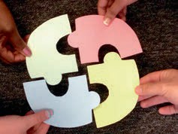

Name of service: Carer name:
Carer designation:

Name of person being supported:

I am aware of and understand the importance of the following:

1. What health screening the person I am supporting needs and why.

2. What the potential barriers could be for them and how we may be able to overcome these.

3. That I have a very important role in supporting this person with health screening familiarisation and desensitisation.

4. That I need to support this person with the ‘health screening homework’, in between clinical sessions/appointments.

5. That I need to ensure others are supporting them with this when I am not available.

6. That I need to work together with the person I am supporting, their GP and other clinicians involved, so that their health needs can be met.

Signature of carer:

Health screening story – template
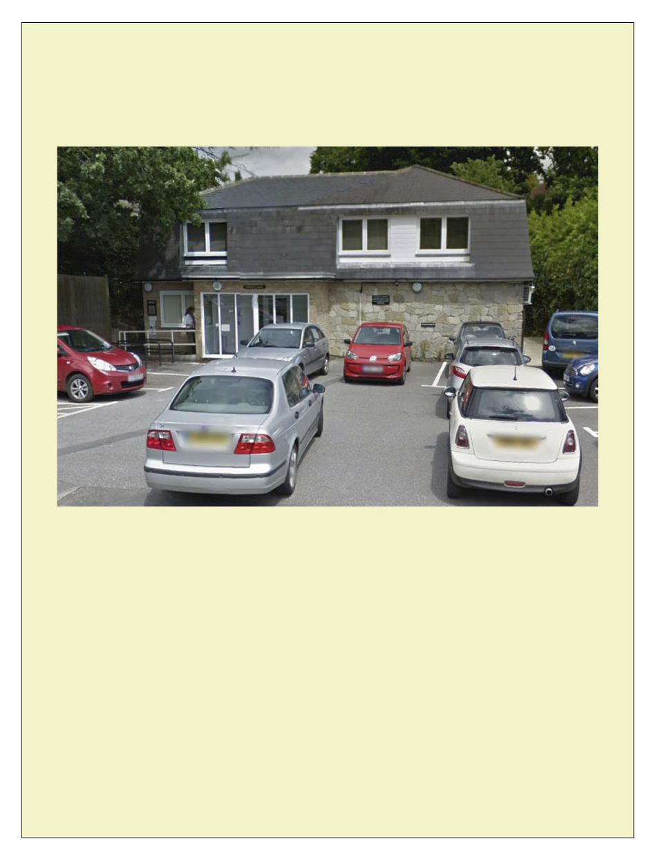

Going for a health check

Kingswood Surgery

A social story about going for a health check.

To be read every day for a week before I go for my health check.

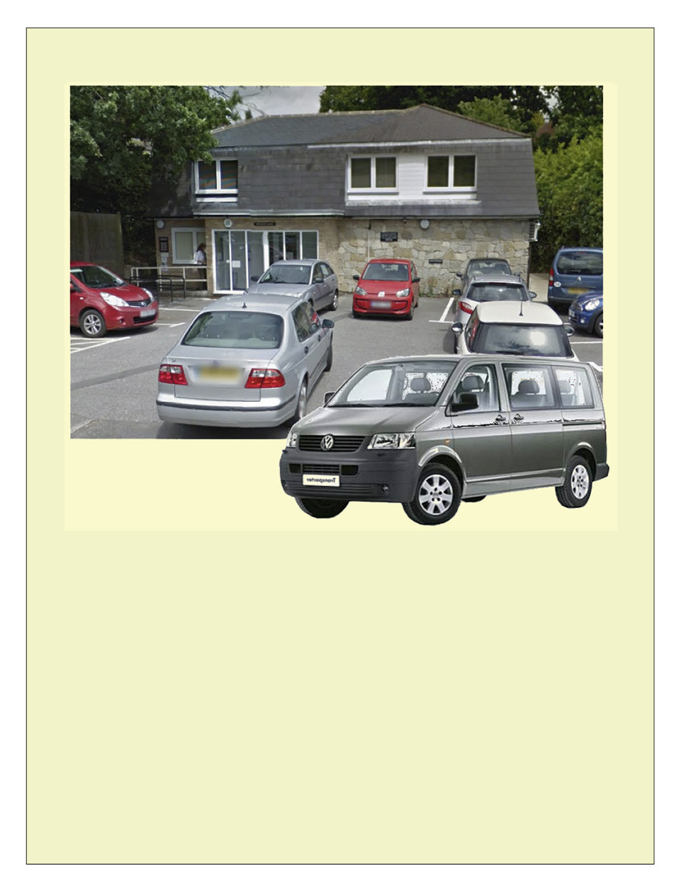

I am going to the doctors. I will go in the car.
I might see a doctor or a nurse.

This is to check my health.

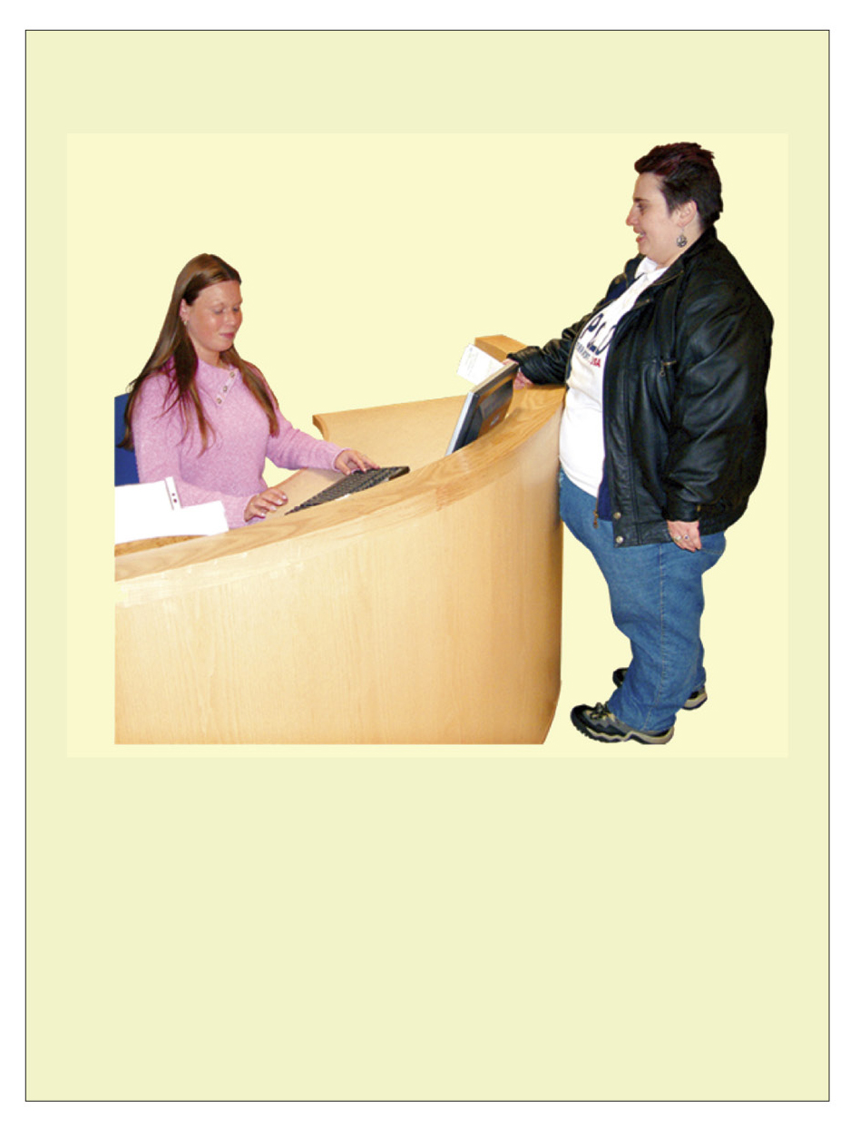

I will tell the receptionist my name.

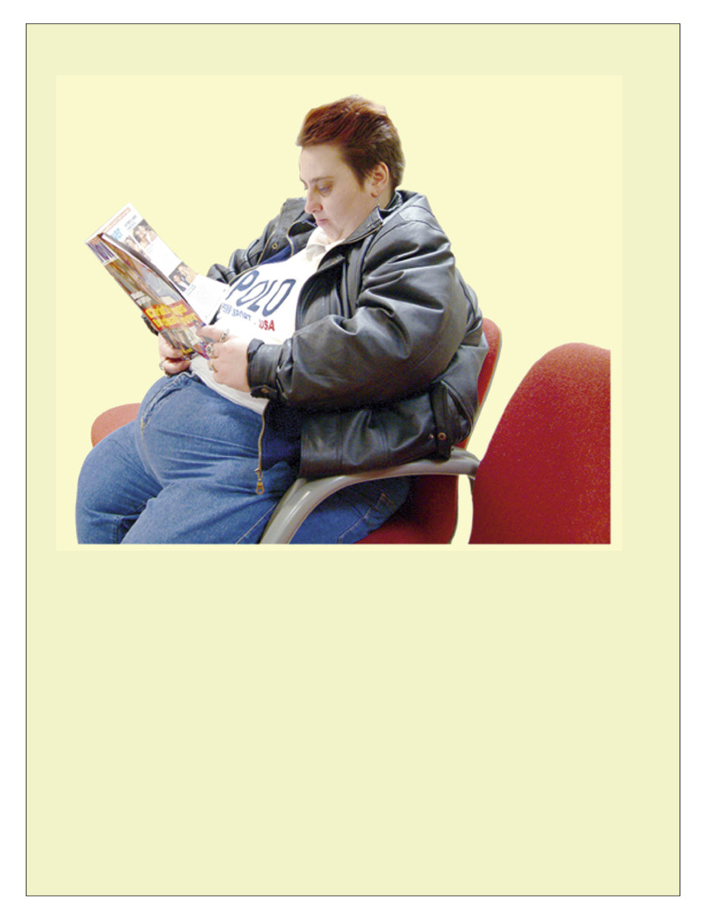

I need to wait in the waiting room. There might be other people there.

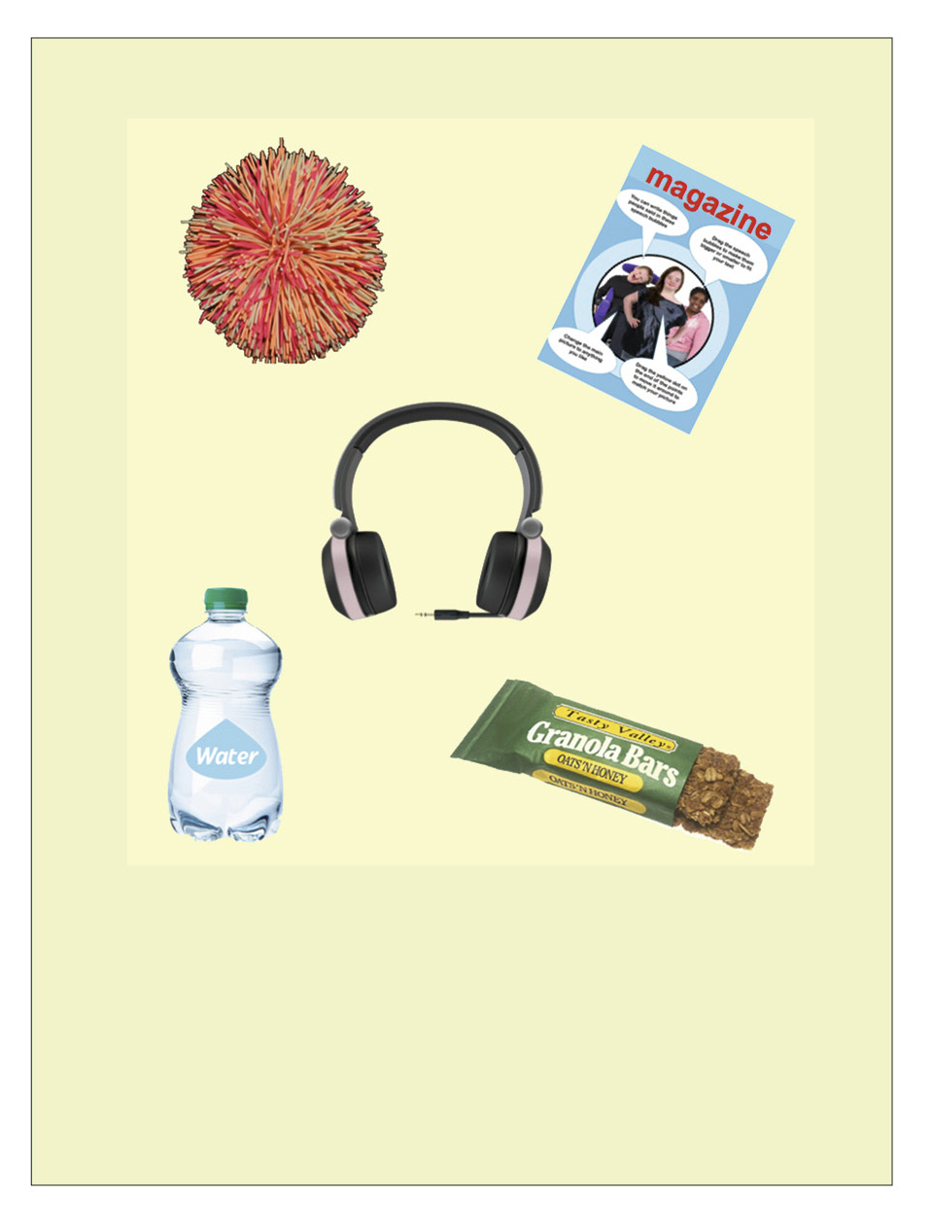

I will take something to do while
I wait and listen for my name.

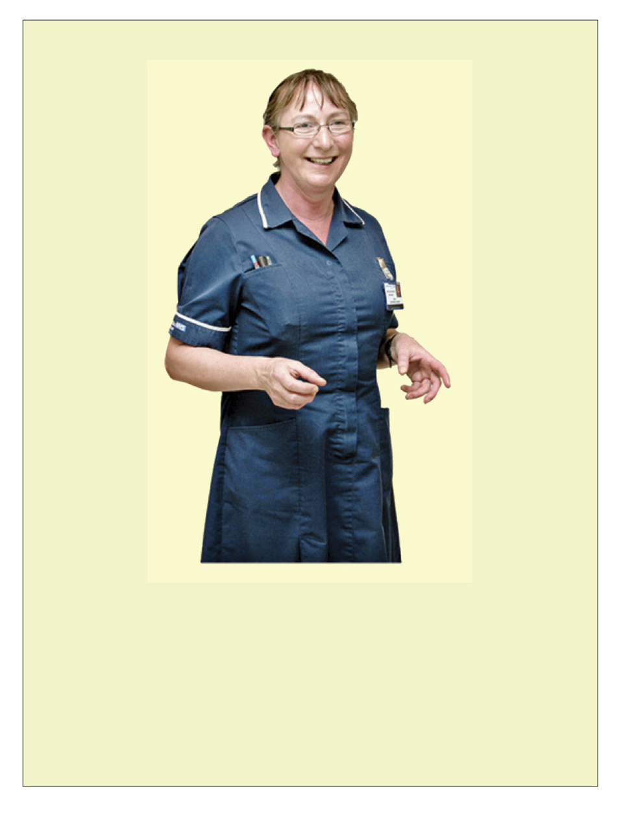

The doctor or nurse will say
‘hello’ and ask me how I am.

The doctor or nurse might weigh me. I will need to take my shoes off.
I will stand on the scales. It will not hurt.

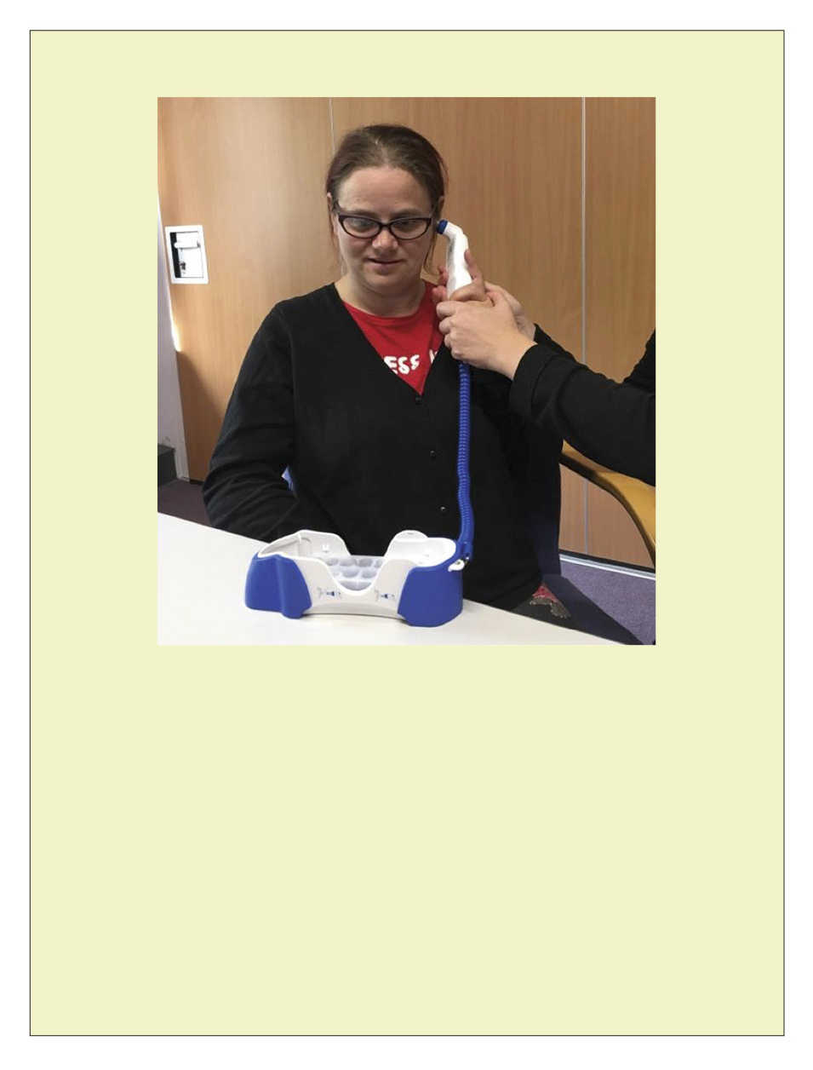

The doctor or nurse might take my temperature. They will hold a thermometer in my ear.
I will hear a beep. It will not hurt.

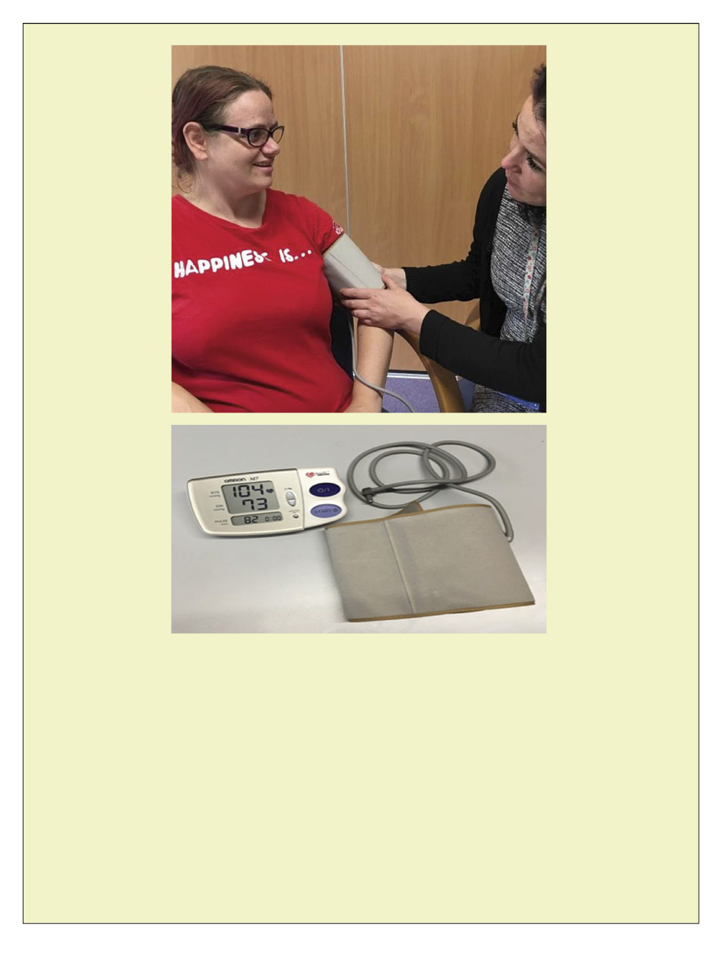

The doctor or nurse might take my blood pressure. They will put a cuff on my arm.
It will get tight and make a small noise. It will not hurt.

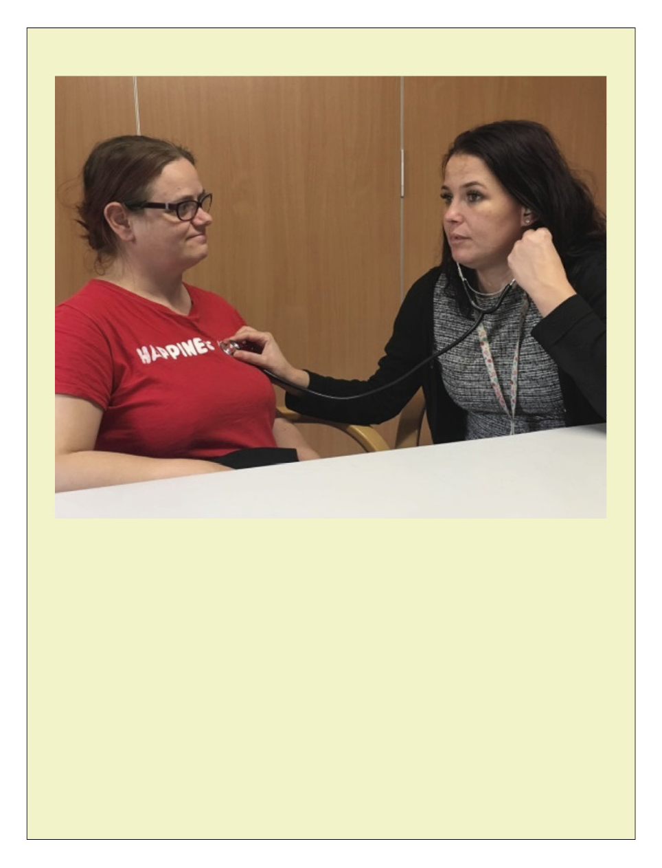

The nurse listens to the individual’s heartbeat.

The doctor or nurse may listen to your heartbeat by placing a stethoscope on your chest.

It will not hurt.

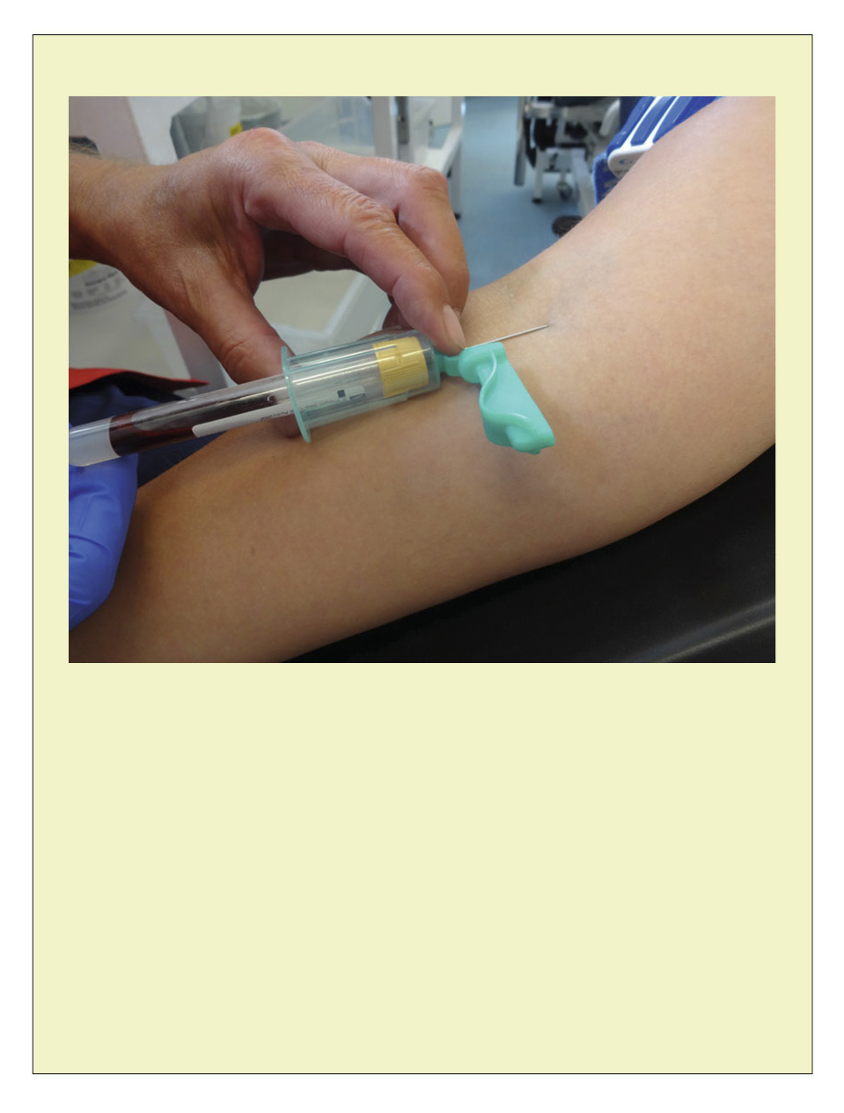

The doctor or nurse may ask you to have a blood test.

A blood test can let you know more about what is happening in your body and whether you need extra help or medication.

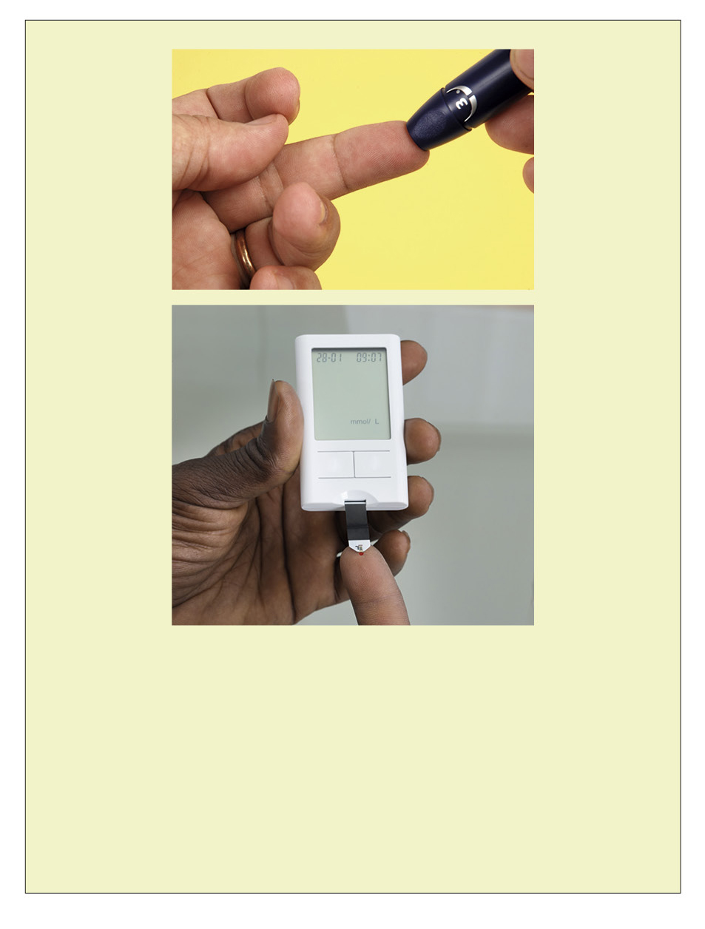

The doctor or nurse may need to do
a finger prick test to check how much sugar you have in your blood.

If you have too much sugar or not enough it can make you feel poorly.

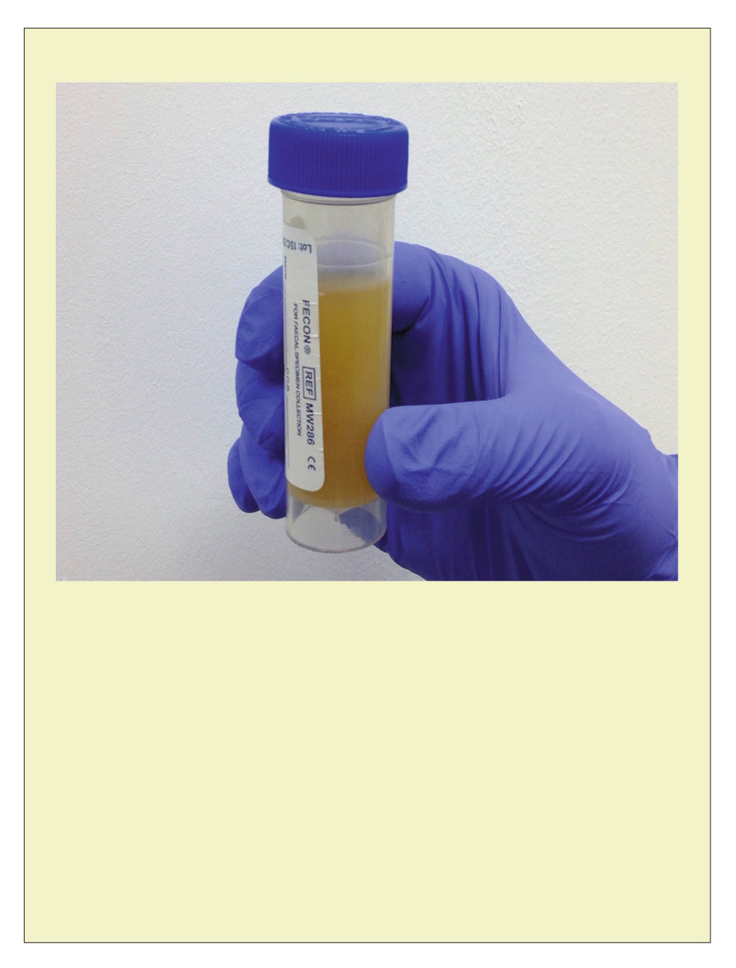

The doctor or nurse may need you to do a urine sample.

This means you will need to wee in a pot so they can test it and make sure you haven’t got an infection.

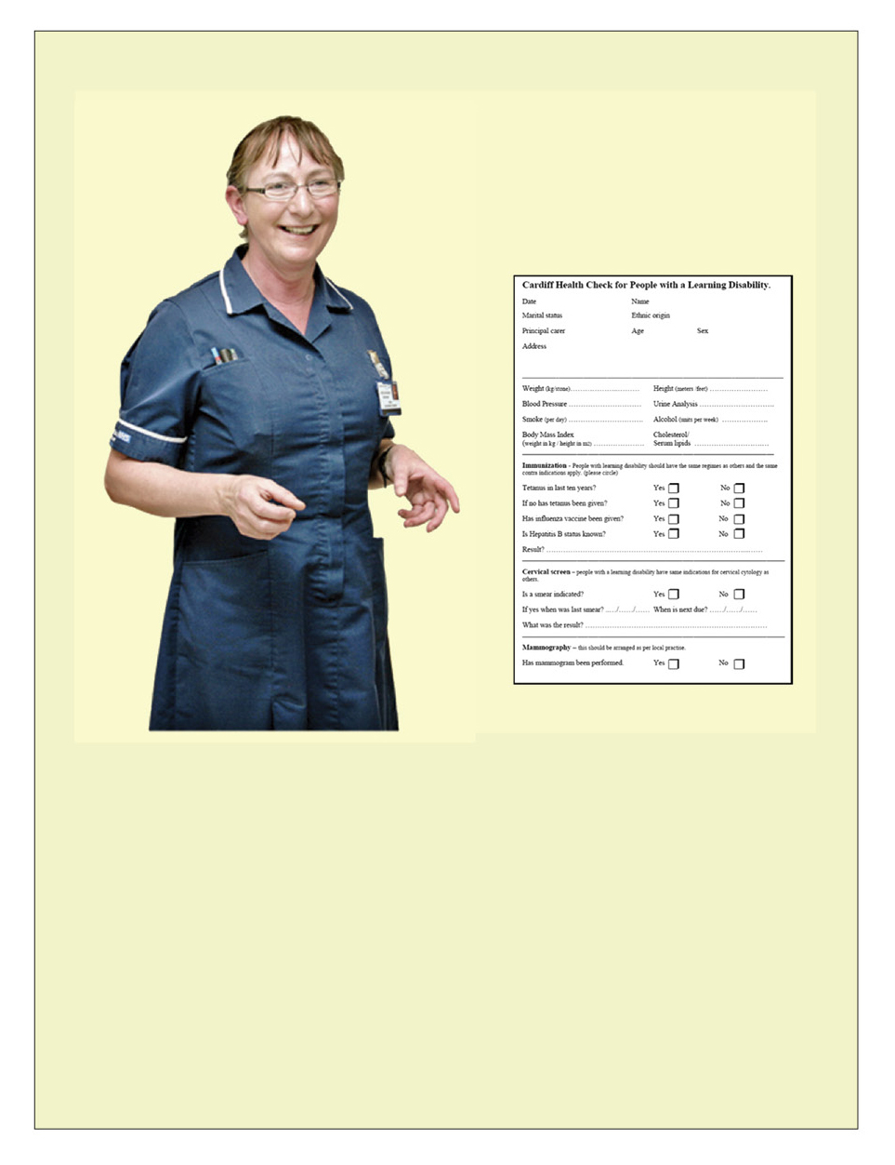

The doctor or nurse might ask some questions
about my health and how I am feeling.

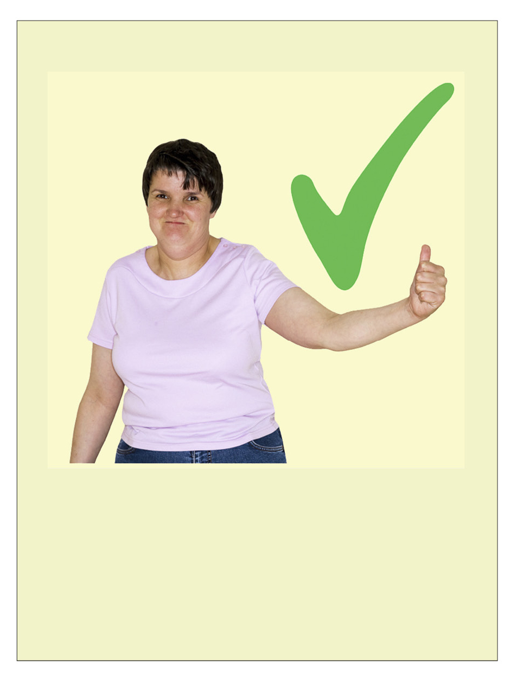

The doctor or nurse were nice.

It was good to have my health check.

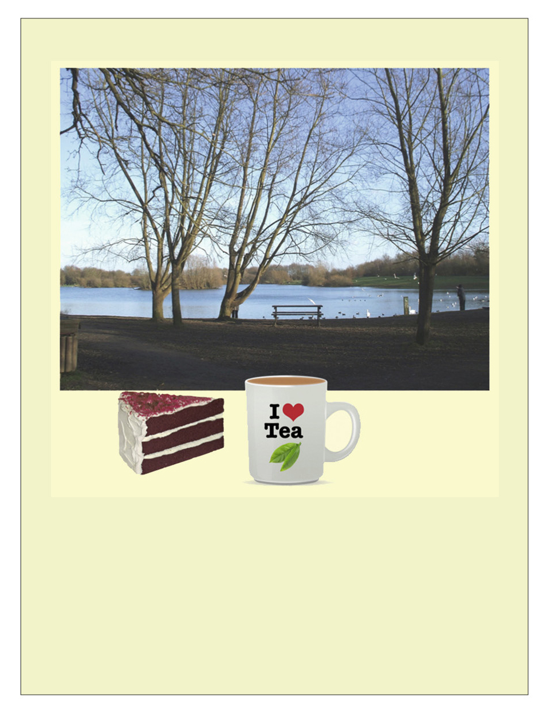

Now I have had my health check, I can do something I enjoy.

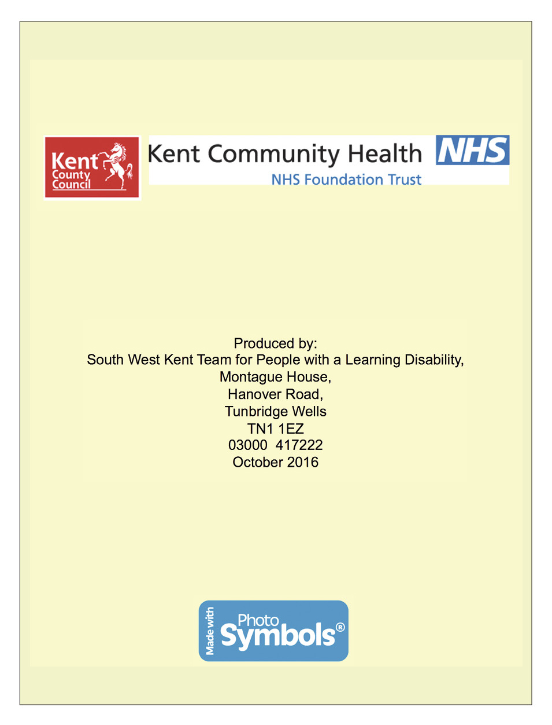
My health screening profile pack

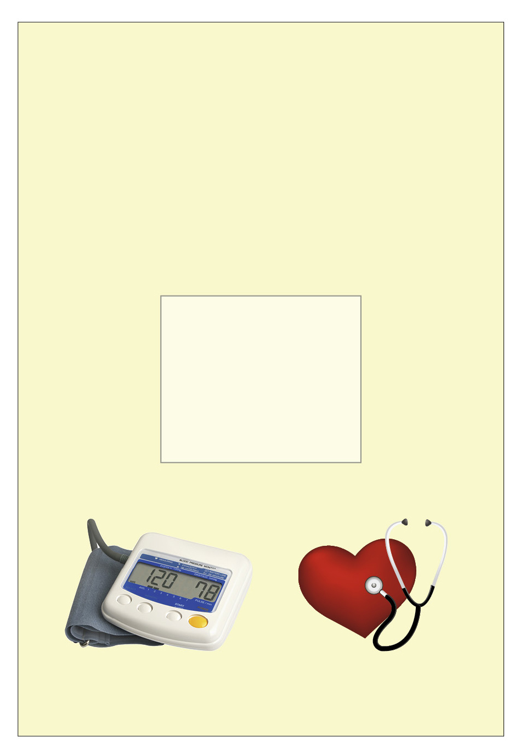

My health screening profile pack

Photograph of individual

Desensitisation profile
NAME:
Photograph
AIM: of individual
What needs to happen? | How? | When? | By who?

My health measurements | NAME: D.O.B: | Comments & contributory factors i.e. anxiety, medication, ill health
 |  | BMI
 |  | Height
 |  | Respirations
 |  | Temperature
 |  | Pulse
 |  | Blood pressure
 |  | Weight
 |  | Date and time

Treatment log sheet
NAME: D.O.B:
Date and time | Equipment item  e.g. blood pressure cuff, tourniquet (pressure band) | How did the individual respond? i.e. smiled, frowned, touched equipment, winced | Staff comments and contributory factors

Desensitisation – monitoring chart | NAME: D.O.B: | Staff signature
 |  | Outcome
 |  | Other specific to individual
Sensory work
e.g. desensitisation to touch
Familiarisation with
equipment
 |  | Health stories used
Familiarisation with environment e.g. trip to
GP/ hospital
 |  | Day and date

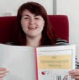
Desensitisation profile (example)
NAME: Jane Bloggs

AIM: To support Jane to have her blood pressure taken successfully with the doctor or nurse; these are steps to encourage this to happen.
What needs to happen? | How? | When? | By who?
Support Jane on trips to the surgery, to help familiarise with journey and environment. | By car – plan transport in advance, ensure transport is available on the day/time of appointment. | Once weekly for one month, then review. | Someone Jane trusts i.e. key worker.
Jane needs to feel reassured and safe. | Jane likes to take her ‘twiddle’ with her, or a snack/drink and go with someone she knows. These help her to feel more relaxed and safe.  Jane to be met at the door by the practice nurse and taken to the room with her carer. | Whenever Jane goes to medical appointments or when she visits the surgery.  For each  blood pressure appointment. | Someone she trusts.  Practice nurse
‘Reinforcer’ to be given following any appointment or visit. | Offer Jane an activity either when out or when she returns home i.e. go for a walk, snack, coffee or something individual to her. Give verbal praise. | Whenever she is supported  to a medical appointment. | Someone who  Jane trusts.
Communicate with Jane using her preferred method of communication. | Use blood pressure cuff as object of reference.  Go through health story at each step. Use Makaton for key words. | Before, during and following appointments. | Someone who  Jane trusts.
Go through Jane’s health story with her. | Allocate one-to-one time, encourage Jane to look at the story. | Every day in the seven days prior to the appointment. | Whoever Jane is comfortable with and trusts.
Jane to become familiar with the blood pressure cuff and machine. | One-to-one time to be given  to Jane to work through blood pressure desensitisation guidelines. | Every day for five minutes. | Jane’s keyworker or identified staff she trusts.

What is flu?

Flu is like a cold but a lot worse. You might:

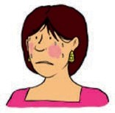 Feel very hot 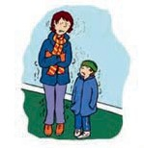 Feel chilly Have a headache Ache

Have a sore throat and cough

Why should I have a flu injection?

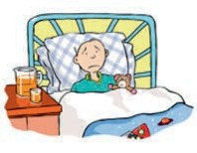
Some people stay in bed a few days and then feel better

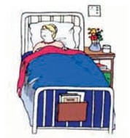
Flu can be bad for people who already have an illness or live with a lot people

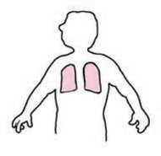
If the flu gets to your
lungs you will need to go to hospital

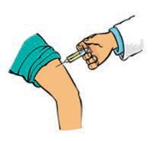
The flu jab helps your body fight the flu germs

What happens at a flu injection?

You will go to the doctors

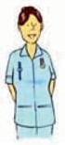
The nurse will talk to you about the injection

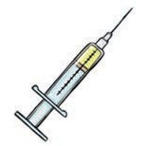
The nurse will put the medicine in a syringe

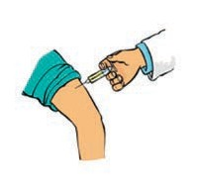
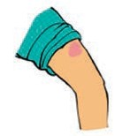 The nurse will clean your arm

The nurse will give you the injection

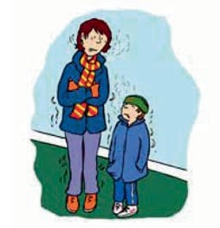
What is flu?

You might feel very hot

What is flu?

You might feel chilly

What is flu?

You might have a headache

What is flu?

You might ache

What is flu?

You might have a sore
throat and cough

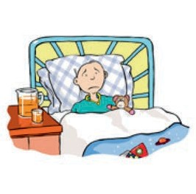
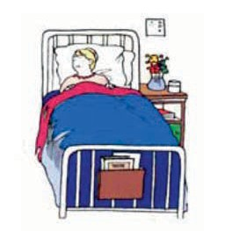
Why should I have a flu injection?

Some people stay in bed a few days
and then feel better

Why should I have a flu injection?

Flu can be bad for people
who already have an illness
or live with a lot people

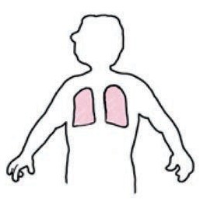
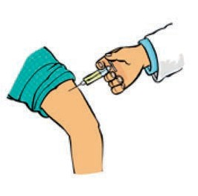
Why should I have a flu injection?

If the flu gets to your lungs you will need to go to hospital

Why should I have a flu injection?

The flu jab helps your body
fight the flu germs

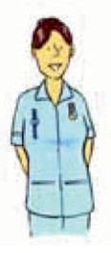
What happens at a flu injection?

You will go to the doctors

What happens at a flu injection?

The nurse will talk to
you about the injection

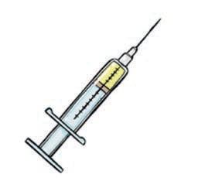
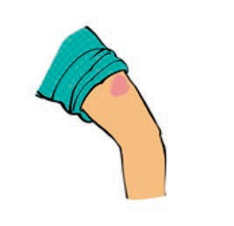
What happens at a flu injection?

The nurse will put the
medicine in a syringe

What happens at a flu injection?

The nurse will clean your arm

What happens at a flu injection?

The nurse will give
you the injection

Adapted from NHS leaflet Seasonal Flu: Protect yourself and other people available here: http://www.cnwl.nhs.uk/wp-content/uploads/2012/04/Easy-read-flu-leaflet.pdf

Licensed under the Open Government Licence v3.0.

Progressive muscle relaxation (PMR)

The idea of this relaxation exercise is to help you learn how your body feels when it is tense, and how it feels when it is relaxed.

You can choose to do this exercise:

1. When you feel yourself becoming tense.
2. When you know something is coming up that will make you feel stressed.
3. As a regular thing no matter how you are feeling.
4. Or all 3!!

Before you start

1. Find a quiet room, not too warm or cold.
2. Make sure you will not be disturbed for about 30 minutes.
3. Find a comfortable chair.
4. Sit down with your feet flat on the floor and your hands resting on your knees.

Breathing

1. With your hand, feel where the bottom of your ribs are.
2. This is roughly where the bottom of your lungs are too.
3. Keep your hand there and breathe IN.
4. You should feel your stomach move OUT.
5. Now breathe OUT slowly.
6. You should feel your stomach move IN.
7. This shows you are using your lungs properly.
8. Breathe in slowly to the count of 5.
9. Hold the breath in for the count of 1.
10. Breathe out slowly to the count of 5.
11. Do this 5 times before starting the muscle relaxation.

Muscle relaxation

Head and face
1. Lift your eyebrows up as high as you can.
2. Hold this while you breathe in to the count of 5.
3. As you breathe out, let your eyebrows drop back down.
4. Your forehead should feel nice and loose and relaxed.

5. Wait for the count of 10 and repeat.
6. Screw your eyes and nose up as tightly as you can.
7. Hold this while you breathe in to the count of 5.
8. As you breathe out, let your eyes and nose relax.
9. Wait for the count of 10 and repeat.
10. Bite your teeth together and pull back the corners of your mouth so you feel your chin and cheeks tighten.
11. Hold this while you breathe in to the count of 5.
12. As you breathe out, let your mouth and cheeks relax.
13. Wait for the count of 10 and repeat.

Neck and shoulders
1. Lift your shoulders up as high as you can.
2. Feel the muscles tense across the back of your neck and shoulders.
3. Hold this while you breathe in to the count of 5.
4. As you breathe out, drop your shoulders back down and feel the muscles relax.
5. Wait for the count of 10 and repeat.

Arms
1. Make a tight fist.
2. Pull your elbow into the side of your body.
3. Feel how hard the muscles are in your hand and arm.
4. Hold this while you breathe in to the count of 5.
5. As you breathe out, let the muscles in your arm and hand relax.
6. Your arm should feel all loose and floppy.
7. Wait for the count of 10 and then do it again.
8. Wait for the count of 10 and then do steps 1 to 7 for the other arm.

Stomach
1. Pull your stomach in as far as you can so that the muscles feel hard.
2. Hold this while you breathe in to the count of 5.
3. As you breathe out, let your stomach relax.
4. Wait for the count of 10 and repeat.

Legs
1. Lift your leg off the chair, make sure the thigh is lifted off too, and point your toes.
2. Your leg will shake a bit but that is good, that means the muscles are tense.
3. Hold this while you breathe in to the count of 5.

4. As you breathe out, let your leg slowly drop back down and rest your foot back on the floor.
5. Wait for the count of 10 and repeat.
6. Wait for the count of 10 and then do steps 1 to 5 for the other leg.

How to relax when you are out and feeling anxious or tense

STOP

SHOULDERS DOWN

Take 3 deep breaths

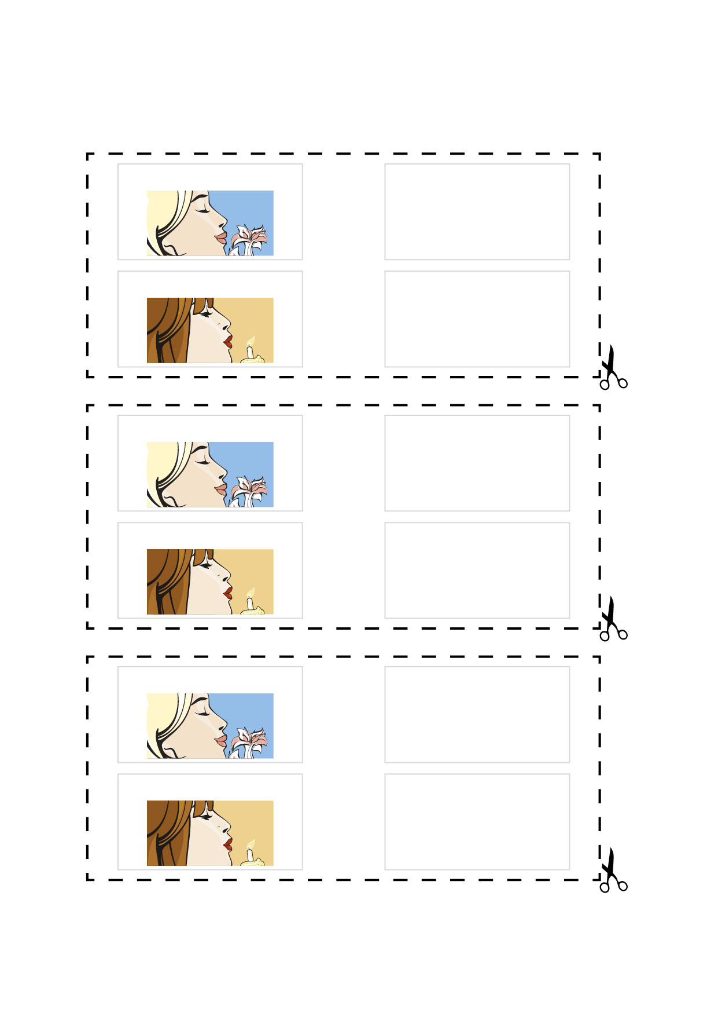

Breathe in through nose

Breathe in for

1 2 3 4 5

Blow out of mouth

Breathe out for

1 2 3 4 5

Breathe in through nose

Breathe in for

1 2 3 4 5

Blow out of mouth

Breathe out for

1 2 3 4 5

Breathe in through nose

Breathe in for

1 2 3 4 5

Blow out of mouth

Breathe out for

1 2 3 4 5

NOW CARRY ON SLOWLY

