Handout 2.1: Case study – Robert

Robert is a 21-year-old man with moderate learning disabilities and autism. Robert lives at home with his parents and younger siblings. He attends a day service on a residential site which the family are hoping he will be able to access in the future.

Robert is a tall man, 6′ 4″, with a very high BMI. When Robert becomes anxious he can become very challenging towards the environment, others and himself.

Robert’s anxiety increases if there are unexpected loud noises and if other people invade his personal space. He does not like to be in crowded situations. Robert has no concept of time.

If distressed, Robert shouts loudly and jumps around the room, knocking over whatever is in his path. He has been known to smash windows and punch through doors when very upset. If another person is in his way at these times he will hit out at them and also hit his own head with his fist and bite his own hand.

Robert makes vocalisations and can use some Makaton signs. He has no speech. He is able to identify with pictorial information and photographs.

Robert likes the sensation of popping bubble wrap and this is a calming activity for him. He also enjoys blowing bubbles, listening to music, and going out to cafés for lunch/snacks. Robert also has a particular interest in Thomas the Tank Engine DVDs and will watch these for hours if left on his own. Robert requests a can of coke
every day which he walks to the local shop to buy with support.

Robert had a history of ear infections as a child and had to have grommets (a thin tube inserted that drains fluid). He has negative associations with health settings, particularly hospitals, due to his experiences as a child and the associations with pain. His parents discussed Robert needing to have PRN medication and being ‘held down’ as a child for any medical interventions to take place.

During the screening process it became apparent that since Robert had transferred to adult services it had not been possible to achieve any health screening at all with him due to his high anxiety and subsequent behaviour in this area. Robert’s consultant psychiatrist was concerned regarding the high levels of risperidone (an antipsychotic) he was prescribed and wanted weekly blood pressure readings, weight checks, a blood test and ECG.

Handout 2.2: Case study – Darren

Darren is 24 years old, He has a severe learning disability, autism, epilepsy and tuberous sclerosis. He lives in a residential setting with six other people.

Darren can become very anxious when in crowded environments or if people are in his personal space. He does not like to be touched by others unless he has initiated it.

Darren likes to hold a ‘twiddle’ at eye level and spins this when he is not directly engaged in an activity. Darren will take off one of his shoes and suspend it by the laces to ‘twiddle’ in the absence of anything else available.

Staff find it hard to engage Darren in activities in the home environment. He does however enjoy car rides, horse riding and picnics. Darren has two members of staff that he has a good rapport with and appears happy and relaxed when he is with them. Darren finds new environments difficult and becomes highly anxious when entering an unknown building.

Darren has no speech but makes loud vocalisations. He does not use Makaton or a picture exchange communication system (PECS). Darren will look fleetingly at pictures shown to him but engagement is limited. If his anxiety levels increase, Darren will begin rocking and screaming/shouting very loudly. This can escalate to hitting out and biting others.

During the screening process it has been identified that Darren has not had any health screening or medical intervention since he lived in children’s services (age 19). A previous ‘OK Health Check’ completed by nursing has identified a change in seizure pattern and an increase in frequency of nocturnal seizures. It also highlighted within a medical report from the tuberous sclerosis consultant in the children’s services, that yearly scans are recommended to monitor tumours growing on Darren’s brain. This has not been achieved due to Darren’s anxiety and subsequent
behaviour.

Handout 2.3: Case study – Thomas

Thomas is a 35-year-old man who has a moderate learning disability and autism. He experiences very high levels of anxiety at times, when he can become challenging towards others.

He lived at home with his parents and residential school until the age of 19, when he moved into the residential setting in which he currently lives. Thomas now lives with seven other men with learning disabilities and autism.

During the health screening process it has been identified that Thomas was prescribed a very high dose of anti-psychotic medication. The consultant psychiatrist involved wants to significantly reduce this dose and was concerned regarding potential longer term side effects and the impact on Thomas’ health if he remained on this dose.

Thomas’ parents and staff team are very anxious regarding the potential reduction of medication, as a previous attempt resulted in a considerable deterioration of his behaviour, including significant injury to others and inability to access the community. The overall consequence seriously affected Thomas’s quality of life. Thomas, staff and his family feel he is the happiest he has been on this level of medication and that he has a good quality of life now.

Thomas’ GP and consultant psychiatrist requested regular blood pressure monitoring and a blood test in the first instance.

Thomas is prescribed PRN medication for when he becomes distressed and is at risk of harming himself or others. He is able to consent to taking his PRN medication and on occasions has asked for this to be administered.

Thomas has very high anxiety levels regarding accessing the GP and has not been able to tolerate any screening. He has not had a blood test since he was in children’s services due to his extreme anxiety in relation to this and subsequent challenging behaviour. Thomas does not like entering any medical buildings and becomes anxious meeting new people. Thomas has an excellent rapport with one female member of staff and his anxieties are noticeably reduced when with her. Thomas needs a very structured routine and becomes distressed if this is not followed.

Thomas is able to make day-to-day decisions e.g. about activities, menu planning, who he would like to spend time with, and is able to communicate this to his carers. He is able to tell the time on the hour and half hour. Thomas enjoys eating out, shopping for personal items, spending time outdoors, going for walks, looking through magazines with staff and posting letters.

Handout 2.4: Case study – Maggie

Maggie is a 45-year-old lady with moderate to severe learning disabilities and Down’s syndrome. She lives in a supported living setting.

Maggie is a very shy introvert lady when she is with people she does not know and chooses to withdraw when she feels uncertain or anxious. She has very high anxieties regarding any health screening and has been unable to get to a GP appointment since living at her current placement (six years). The GP has visited her at home but has been unable to carry out any screening.

When the staff attempted to support her to the GP in the past she would not enter the surgery, becoming very distressed in the car if she was asked to get out to go into the building.

Maggie requires a Well Woman check including blood pressure and her GP also wants Maggie to have a blood test due to concerns regarding her thyroid function.

Maggie bursts into tears if she is in situations that are new to her or if she does not understand what is going to happen next.

Maggie has some verbal communication and has a few phrases that she repeats. Maggie responds well to visual information and pictures/photographs. Maggie enjoys watching Batman on television and likes the theme tune from this. She also enjoys looking at magazines and listening to music.

Maggie has a good rapport with her sister and enjoys seeing her once a fortnight.

Maggie attends a day service four days per week and becomes distressed if her normal routine is changed.

Handout 2.5: Desensitisation screening tool

NAME: D.O.B: NHS NO:
Health screening required:
General health screening (BP, height, weight, pulse, temp, heart rate) □
Blood test □
Electrocardiogram (ECG) □
Flu vaccination □
Blood glucose (BG) □

Other health screening, please state:

1. When did the individual last have health screening with their GP/practice nurse?

2. Has the GP/psychiatrist highlighted a clinical need for desensitisation work?
Please state:

3. Have there been difficulties accessing health screening in the past? (please circle)

Sensory Environment Communication
Past history/experiences

Anxiety levels/behaviour

Difficulty meeting new people/accessing new environments

Other

[Complete Handout 2.7: Barriers to health screening checklist]

Handout 2.5: Desensitisation screening tool contd.

Clinical priority: (Please identify priority and tick relevant box)
HIGH: □

Individual is requiring health screening urgently due to a clinical need
e.g. blood test, ECG.
MEDIUM: □

Individual requires health screening as part of the directed enhanced
services/annual health check (Cardiff health check).
LOW: □

Individual has no immediate health screening need but may require
screening in the future and requires preparation.

Desensitisation screening tool
Have any areas of risk been identified? (Complete a risk assessment.) Please state:

Does the individual consent to the health screening? Is a capacity assessment required? Please give details:

Does the individual require an onward referral/signposting e.g. speech and language therapy. Please state:

Does the individual require: (Please tick relevant boxes)
One-to-one input: □ 
Desensitisation clinic: □ 
Do the individual and their carers require education around the process? □

Environment
 Unfamiliar clinical environments can cause anxiety.
 Entering new buildings and seeing medical staff can be difficult to cope with.
 Unfamiliarity with medical equipment and how it is used can increase anxiety levels further.

Past experiences
 Past negative experiences can have a major impact when accessing health settings.
 Some individuals may have experienced being restrained in the past when
having medical interventions.
 Individuals may associate health settings with pain.
 An emergency medical intervention may leave the person fearful and anxious.

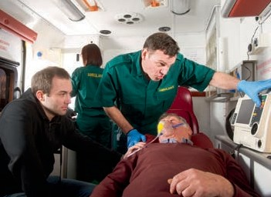

 The individual may not have been involved in medical decisions made about them previously and feel out of control.

Waiting times
 Waiting for long periods of time in a busy waiting room for appointments can increase anxiety.

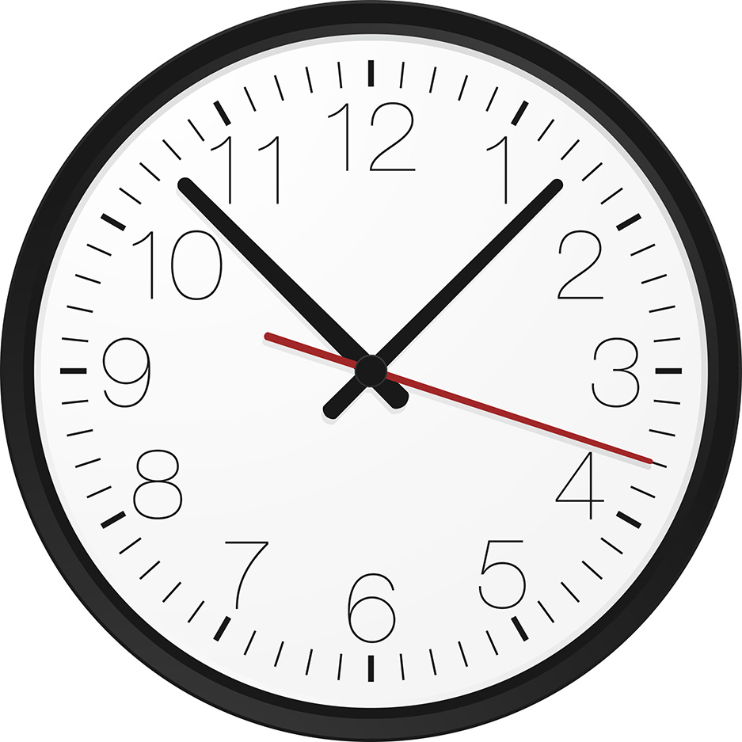

Communication
 Often people with a learning disability are not supported appropriately prior to an appointment.
 They may not be given information in a way that they understand and can process, regarding their health appointments.
 They may not understand why they are going to the GP, for example what will happen when they get there, who they are going to meet.
 Medical jargon can be overwhelming.

 Attempts at health screening without appropriate preparation and explanation exacerbate anxiety.

 Practitioners who may not understand the individual’s communication needs may concentrate on giving information to their carer. This may make the individual feel excluded and not in control of their personal information.
 For people with severe and profound learning disabilities, the whole concept of health screening may be too abstract for them to understand.

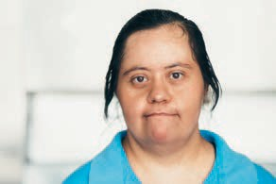
?

Support
 Being supported by a person they know well and trust can provide an individual with a degree of ‘safety’ in unfamiliar environments or situations. Without this, anxiety levels can be increased, creating significant barriers.

Sensory issues
 Many people with autistic spectrum disorder (ASD) have difficulty processing everyday sensory information such as sounds, sights and smells. This is called having sensory integration difficulties.
 People with ASD can become over-sensitive or under-sensitive in any or all of the seven senses: sight, sound, touch, taste, smell, balance and personal space.

Sight
 People who have over-sensitive sight, for example, may have distorted vision;
objects and bright lights can appear to jump around.

 Imagine being in the building below if you have over-sensitive sight. How would that make you feel and behave?

 Under-sensitive sight can mean objects may appear quite dark or lose some of their features.

Sound
 If an individual has over sensitive hearing, noise can be magnified and sounds become distorted and muddled.
 Busy hospitals and GP surgeries can be very overwhelming with many noises and sounds from all directions. This can cause sensory overload.
 If the individual’s hearing is under-sensitive, they may not acknowledge particular sounds, or they may only hear sounds in one ear and/or partially in the other.

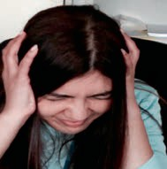

Touch
 Under-sensitive touch means an individual may need to hold others tightly before there is a sensation of having applied pressure. They may have a high pain threshold; they may self-harm.
 Over-sensitive touch may mean touch can be painful and uncomfortable. The individual may not like to be touched; they may dislike having anything on their hands and feet.

Personal space
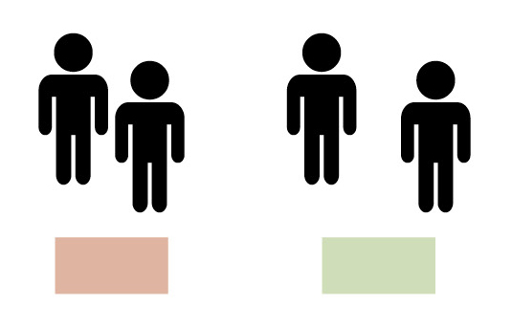
 For some individuals having other people in their personal space can be traumatic. This can make it very difficult for practitioners to provide health screening.

not ok ok

 GP surgeries and hospitals can, therefore, cause sensory overload due to noise, crowds, lights sounds etc. Additional sensory impairment such as hearing and visual loss may also increase anxiety and confusion in unfamiliar environments.
 People with sensory integration difficulties who struggle to deal with all this information are likely to become stressed or anxious, possibly feel physical pain or become challenging to themselves or others.

Behaviour
If an individual experiences any one or a combination of the barriers mentioned it could lead to:

 refusal of future appointments
 becoming distressed and anxious during an appointment
 increasing negative experiences for the individual associated with medical appointments
 challenging behaviour towards the environment, themselves or others, thus exacerbating their negative experience and relationship with the health setting.

Barriers to health screening checklist
 | Yes | No | Don’t know | Details
ENVIRONMENT Experiences anxiety about:
New environments, entering new buildings.
Meeting new people.
Medical equipment.
Waiting.
PAST EXPERIENCES
Previous negative experiences with medical appointments.
Associates health settings with pain.
Has experienced restraint in the past when undergoing medical procedures.
Had a lot of medical appointments/
treatment as a child.

Barriers to health screening checklist
 | Yes | No | Don’t know | Details
COMMUNICATION
Requires prior support to understand health appointment.
Requires visual information to back up process.
Concept of health screening too abstract.

SENSORY INTEGRATION DIFFICULTIES
SIGHT
Visual impairment diagnosis.
Under-sensitive e.g. objects appear dark, lose some of their features.
Over-sensitive e.g. distorted vision: objects and bright lights can appear to jump around .
Other:

Barriers to health screening checklist
 | Yes | No | Don’t know | Details
SENSORY INTEGRATION DIFFICULTIES
SOUND
Hearing impairment diagnosis.
Under-sensitive e.g. only hear sounds in one ear, may not acknowledge particular sounds.
Over-sensitive e.g. noise can be magnified and become distorted.
TOUCH
Under-sensitive: e.g. stands too close to others, bumps into people, has difficulty navigating rooms.
Over-sensitive e.g. touch can be painful and uncomfortable, does not like to be touched, dislikes
having anything on hands and feet.
Does not like others in their personal space.
Has become very anxious/ distressed at GP/medical appointments.

Barriers to health screening checklist
 | Yes | No | Don’t know | Details
Has become challenging towards themselves during appointments.
Has become challenging towards others during appointments.
Becomes withdrawn during appointments.
Idiosyncrasies e.g. won’t leave the house if it is raining.
Other:

Handout 2.8: Case study – Maisy

Maisy is a 26-year-old lady with severe learning disabilities, cerebral palsy, epilepsy and visual impairment. Maisy has no peripheral vision. Maisy is a wheelchair user and requires support to mobilise. She has communication difficulties and has three key words that she uses for a number of needs. She lives at home with her mother and father.

Maisy is the centre of her parent’s life and they provide the majority of her care; she accesses respite occasionally.

Maisy has had many hospital admissions in the past due to dehydration, urinary tract infections (UTIs) and the subsequent effects on her seizure frequency.

When confused or distressed, Maisy will grab whatever she can feel or see around her and put it in her mouth and bite it. She also bites her own hand.

Maisy was asked by her GP not to attend the surgery for appointments stating he would visit her at home due to her very loud vocalisations and distress when waiting in reception. There had also been an incident when she grabbed out at a small child in the waiting room.

Following referral to the learning disability team, Maisy was assessed by learning disability nursing as needing health screening desensitisation, with support for her and her family regarding reasonable adjustments being made to enable her to access her GP surgery again.

The screening process highlighted known and potential barriers to health screening including ethical issues relating to the parent’s current approaches.

Barrier/ethical issue | Clinical intervention | Outcome
Parents felt that due
to her severe learning disabilities Maisy should be classed as a child when accessing health services. They did not agree that they could not consent on her behalf. They felt she should just have health screening implemented even if she was showing distress
as she ‘will never understand it’.
Visual impairment. Maisy has no peripheral vision so
becomes startled when approached from the side, causing her to lash out.
Maisy becomes startled by loud or sudden noises. Sometimes this causes her to have a seizure.
The GP has excluded
Maisy from the surgery.

Handout 2.10: Barriers and ethical issues –
developed

Barrier/ethical issue | Clinical intervention | Outcome
The parents felt that due to Maisy’s severe learning disabilities she should be classed as a child when accessing health services. They did not agree that they could not consent on  her behalf. They felt she should just have health screening implemented even if she was showing distress as she ‘will never understand it’. | One-to-one discussion, support and education about transition from child to adult services.  Advice regarding consent and best interests.  Hands on practical support and role modelling re: desensitisation. Showing parents how, step-by-step, Maisy can be familiarised with  equipment, going at her pace and understanding when she wants to engage or stop etc. | Initially the parents were very unhappy and felt it was ‘ridiculous’.  Over time, however, they were able to visually  see positive progress and Maisy becoming comfortable with health screening stages.  Their extensive knowledge and amazing rapport with Maisy informed the whole process.
Visual impairment. Maisy has no peripheral vision so becomes startled when approached from the side sometimes causing her to lash out. | All interventions took place on a one-to-one basis, directly facing Maisy on eye-to-eye level.  People and equipment were always introduced from the front not the side. | Maisy became less anxious and her self-injury and challenging behaviour reduced.  Maisy began to hold equipment and look at it; wearing a BP cuff etc.
Maisy becomes startled by loud or sudden noises. Sometimes this causes her to have a seizure. | Maisy wore ear defenders during part of the session so these could be used in the waiting room.  Desensitised Maisy to the sound of the tympanic thermometer  by initially introducing it from a distance and slowly, over time, getting nearer to her ear. | Maisy found the waiting room less stressful and was not startled by noises.  She became familiarised with the tympanic thermometer and had her temperature taken.
GP excluding Maisy from the surgery. | Direct enhanced service (DES)  training provided to GPs.  Double appointments were booked to meet with Maisy, parents, GP, and with LD nurse co-ordinating input.  Advice re: desensitisation profile and interventions.  Nursing to support Maisy and parents to GP appointments initially to provide practical hands on support regarding reducing barriers. | GP signed up to DES.  Although initially sceptical, GP was able to visually  see positive steps made by Maisy and that the health screening was achieved.  Nurses were able to phase out support to GP appointments.  The family and GP were able to continue with this.

This scenario is an example of capacity to consent.

Throughout the desensitisation process with support staff and nursing, Thomas was given control over the equipment and could choose what equipment he wanted to use. Lots of reassurance was given and he was able to say ‘stop’ at any point. This increased his trust and confidence in knowing that he would not be made to do something he did not want to do.

When he was ready for his blood test he had several appointments with the practice nurse at the surgery, who implemented all stages except for actually taking his blood. Then an appointment was booked for his first blood test.

At the first blood test Thomas did extremely well but his anxiety was so high he was not able to continue with actually having his blood taken. Lots of positive reinforcement was given as this was an excellent first attempt. We discussed helping Thomas with managing his anxieties and the one off use of medication to help reduce his anxiety prior to the next appointment was introduced. Thomas was able to understand this concept and consented to being administered the smallest possible dose of lorazepam prior to his second appointment, as part of an agreed protocol, to help him feel more relaxed.

Thomas successfully had his blood taken at the second appointment as a result. He has since had a further two blood tests. He did not require medication at either of these appointments.

Therefore, a one off dose was enough to reduce Thomas’ anxieties sufficiently to achieve the first blood test. Because this was then a positive experience for Thomas, he was successful and now aware of how it felt. This reduced his future anxiety regarding blood tests and enabled him to have the two further blood tests without sedation.

This scenario is an example of physical intervention.

The British Institute of Learning Disabilities (BILD) describes physical intervention as: ‘A method of responding to the challenging behaviour of people with learning disabilities and/or autism which involves some degree of direct physical force which limits or restricts the movement or mobility of the person concerned’ (BILD, 2010).

Historically, people with learning disabilities have experienced physical intervention/ restraint in relation to invasive medical procedures such as blood tests which has increased anxiety for those individuals involved.

BILD suggests that 50% of people with learning disabilities and challenging behaviour will have physical interventions used on them at some point in their life (British Institute for Learning Disabilities website: www.bild.org.uk).

This was certainly the case for Thomas in the past and was identified as one of the barriers to him receiving healthcare during the screening process.

Although being restrained had been a very negative experience for Thomas, during the desensitisation process it was identified that he would benefit from some reassuring physical support when having his blood test. This was due to the fact that when it came to seconds prior to actually inserting the needle for his blood test Thomas would automatically flinch. This made it very difficult to continue safely. It was established that his flinching was not non-verbal communication that he did not want to proceed, but an automatic response to the anxiety he felt.

As part of Thomas’ person-centred blood test desensitisation programme, we therefore included a level of physical support to help him with the procedure. This was discussed with Thomas to ascertain what level he would feel comfortable/ happy with. The support agreed was that whilst in clinic, when Thomas had his arm on the pillow, the person supporting him and who he felt safe with placed their hand on his shoulder and forearm and asked him if the level of touch was okay. It was made very clear to Thomas that he could say stop or move his arm at any point and that this was to provide him with reassurance and to support him through the blood test, not to restrain his arm against his will.

In addition to the above, Thomas was encouraged to look at the person supporting them rather than at his arm. Initially this was very difficult for Thomas. Thomas particularly liked cars and had a large collection of car magazines. Thomas chose his favourite magazine to bring and whilst his arm was supported a second carer held the magazine so he could see it and they talked through the cars. This enabled Thomas to focus away from the needle and relax enough for the procedure to take place.

This scenario provides an example of best interest decisions and use of medication.

Maggie is a 45-year-old lady with moderate to severe learning disabilities and Down’s syndrome. She is a very shy introvert lady when she is with people she does not know and chooses to withdraw when she feels uncertain or anxious. When we screened Maggie she had very high anxiety regarding any health screening and staff had not been able to get her to a GP appointment for years. She would not enter the surgery building becoming very distressed in the car if she was asked to get out and enter the building.

Over time Maggie became familiar with the medical environment and equipment. She successfully had a well woman’s appointment.

Due to concerns raised at this appointment regarding her thyroid, the GP requested a blood test. Blood test desensitisation was commenced on a one-to-one basis, however Maggie’s anxiety levels were such that it was not actually possible to take her blood on the first two occasions.

A best interests meeting was held with the GP, learning disability nurse, care manager and house staff. The GP highlighted at this meeting the urgency that Maggie required a blood test for thyroid function.

As a consequence it was determined and agreed between the professionals involved in Maggie’s care that it was in Maggie’s best interest to have a one off prescription for sedation, lorazepam, prior to the blood test. It was agreed this would become part of the desensitisation programme to reduce her anxiety levels and hopefully enable her to have the necessary screening. The GP was the decision maker.

Maggie had the sedation as part of the process and the third attempt at a blood test was successful.

Consequently Maggie is now prescribed thyroxine for an underactive thyroid. Maggie has required sedation for subsequent blood tests and this is reviewed each time as part of the desensitisation process with the GP. The aim is for Maggie to be able to have her blood tests eventually without sedation.

This scenario provides an example of acquiescing.

Roger is a 54-year-old man with Down’s syndrome and moderate learning disabilities. He is a very sociable, friendly and affable man. Roger generally wishes to please others and will often say ‘yes‘ to everything he is asked.

Initially during the pilot project, it was difficult to ascertain whether Roger was actually consenting to treatment and interventions offered, or whether he was acquiescing. Therefore we tailored our communication, observation and interventions with him to ensure we were clear about his wishes at each stage of intervention.

We tailored our communication, observations and interventions by:

 asking open-ended questions, not questions requiring yes/no answers
 using visual aids to show Roger at each stage, what would be happening next.
This increased his understanding of what was happening at that moment, giving him the option to engage or refuse.
 giving Roger extra time to process information given
 observing Roger’s non-verbal communication e.g. although he may be smiling and saying yes, he may also have got out of the chair and be pacing, indicating he is not happy. (On occasions Roger said ‘yes’ and smiled once the intervention had been explained to him but pushed away the equipment when
it was shown to him.)
Giving Roger control and independence with the interventions enabled us to get a clearer idea of whether he was consenting e.g. we gave him the option to choose which equipment he would like to use and he chose the tympanic thermometer, picking it up. We put a new ear cover on it and he put it in his own ear and pressed the button. Although it did not give an accurate reading as it was not placed appropriately in the ear we were able to ascertain that Roger was in agreement for this intervention to take place. We were then able to carry it out again, supporting him, so an accurate reading was obtained.

This scenario provides an example of unwise decisions.

Sam is a 45-year-old man with a mild learning disability. Sam generally eats an unhealthy diet and takes minimal exercise. Sam also drinks over the recommended units of alcohol weekly and often has ‘binge drinking sessions’ with his friends. During the screening process for the pilot project it was identified that the GP had urgently requested blood tests and screening regarding kidney function following physical symptoms experienced by Sam.

Sam was assessed as having the capacity to understand the screening required, why he needed it and the benefits of having it. He was also able to understand the possible adverse effects if he did not have the screening. However, despite further one-to-one work to educate him and encourage him to access the screening required, he continued to refuse.

Sam clearly had capacity to make this decision and this had to be respected, even though it could be considered as unwise.

The GP was informed of Sam’s decision and she advised she would follow up at future appointments regarding any health deterioration, and revisit the information given at our screening.

Sam has since been advised that he will need dialysis, however has continued with his lifestyle choices.

Handout 2.16: Creative techniques

‘Darren did not like being touched at all even by people he knew well, and particularly could not cope with his arms being touched. We started by using objects from a sensory box to see which he liked. A feather was used to stroke his upper arm over clothing initially, then progressed to his hand and arm without clothing. We slowly replaced the feather with a finger increasing the pressure used, then introduced the BP cuff.’

‘We spent Maggie’s first few sessions in the car park meeting and greeting her in the car. Over time we progressed to meeting her outside the surgery door. Then after several weeks she was able to enter the building and came into the consulting room.’

Neville wanted to sing Christmas songs in the clinic as this helped him relax. We all joined in with him then used the tune of his favourite song to sing through what was happening now and next.’

‘Giving Thomas complete control over the sequence of events; enabling him to use equipment by himself and take his own observations, reduced
his anxiety considerably.’

‘

‘Ellie was so anxious around equipment that we spent the first few sessions playing games with her that she instigated, such as “incey wincey spider” and clapping games. We then introduced equipment within the games and she was eventually able to wear the BP cuff and inflate it whilst nurses sang the song with her.’

Maggie burst into tears each time she entered the consulting room. We found linking objects helped. She would bring something to show us each time, after which she relaxed.’

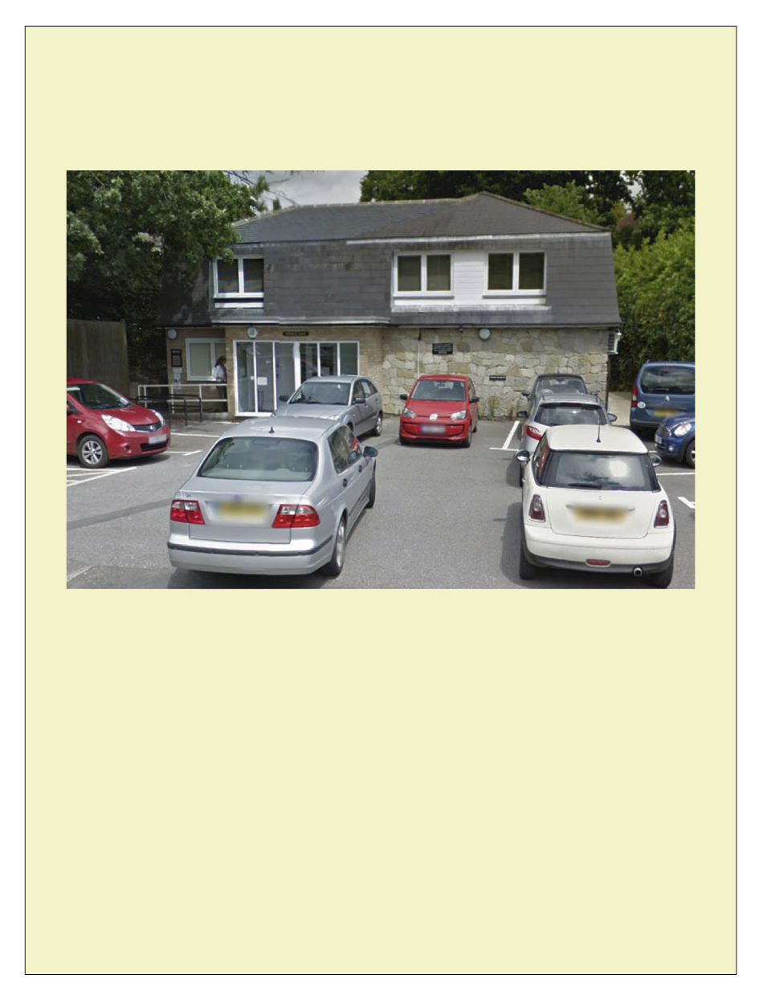

Going for a health check

Kingswood Surgery

A social story about going for a health check.

To be read every day for a week before I go for my health check.

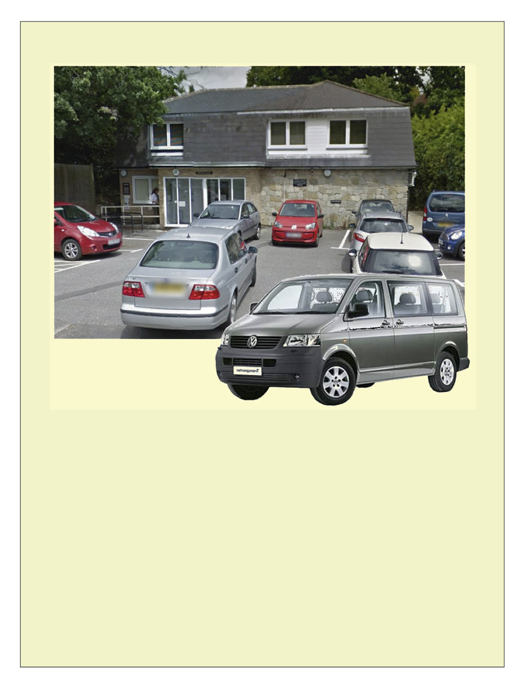

I am going to the doctors. I will go in the car.
I might see a doctor or a nurse.

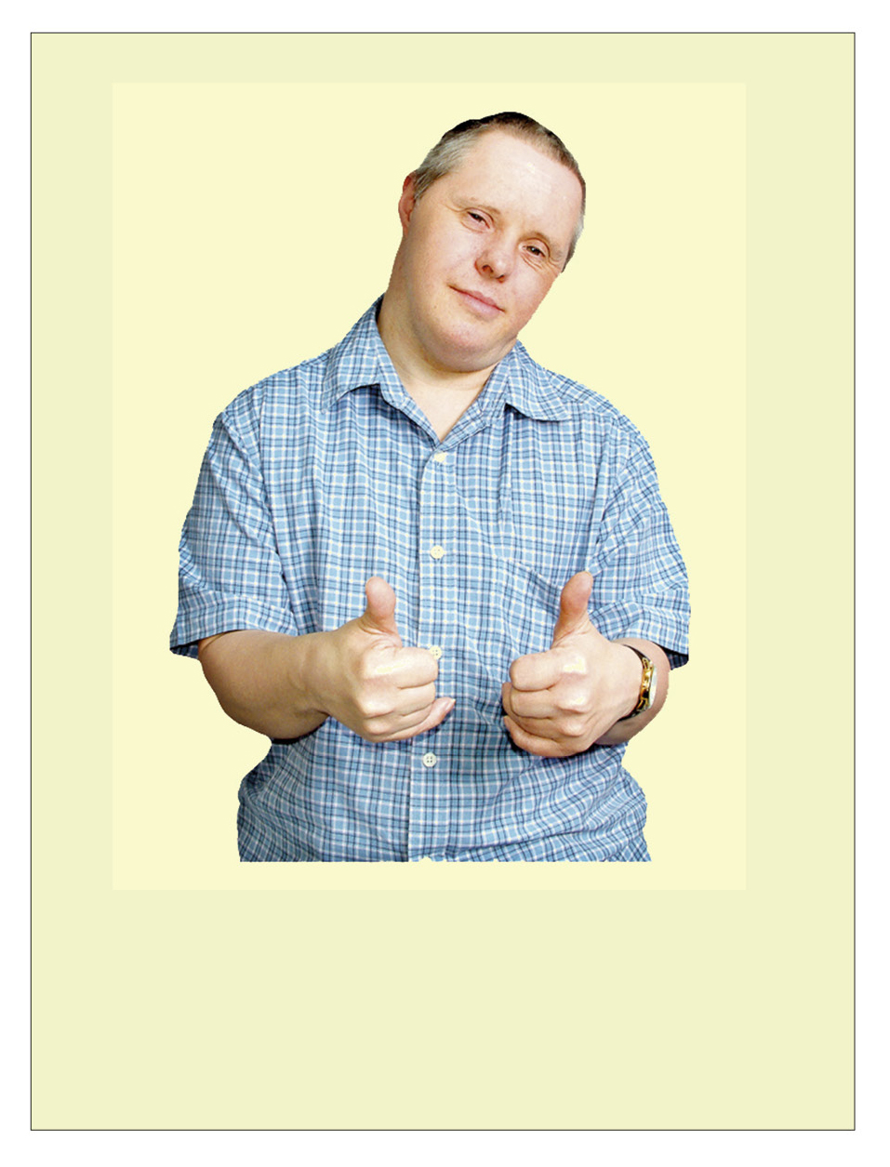

This is to check my health

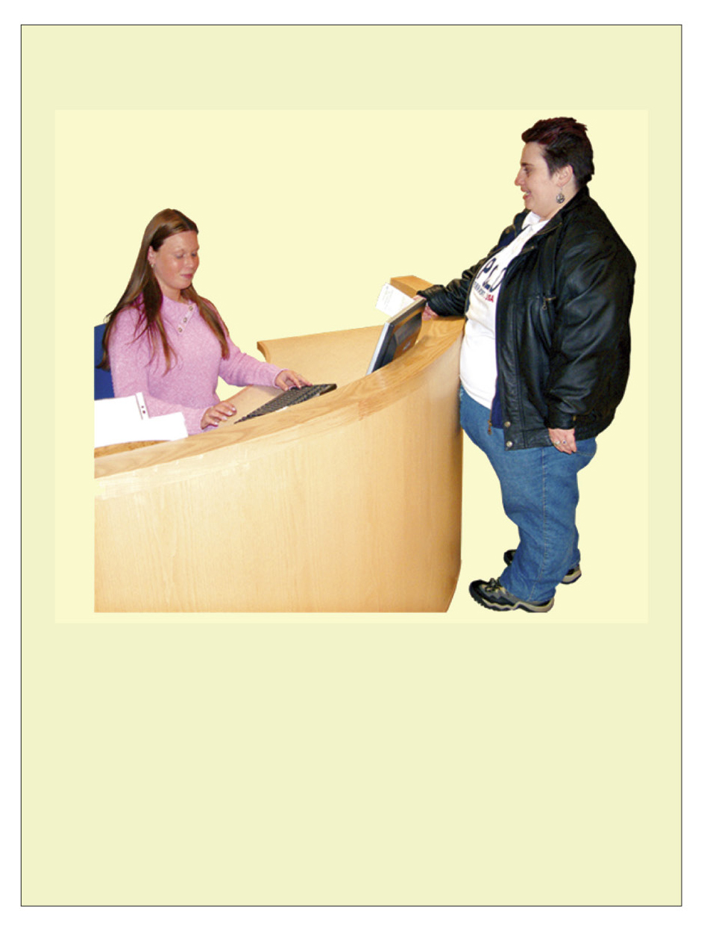

I will tell the receptionist my name.

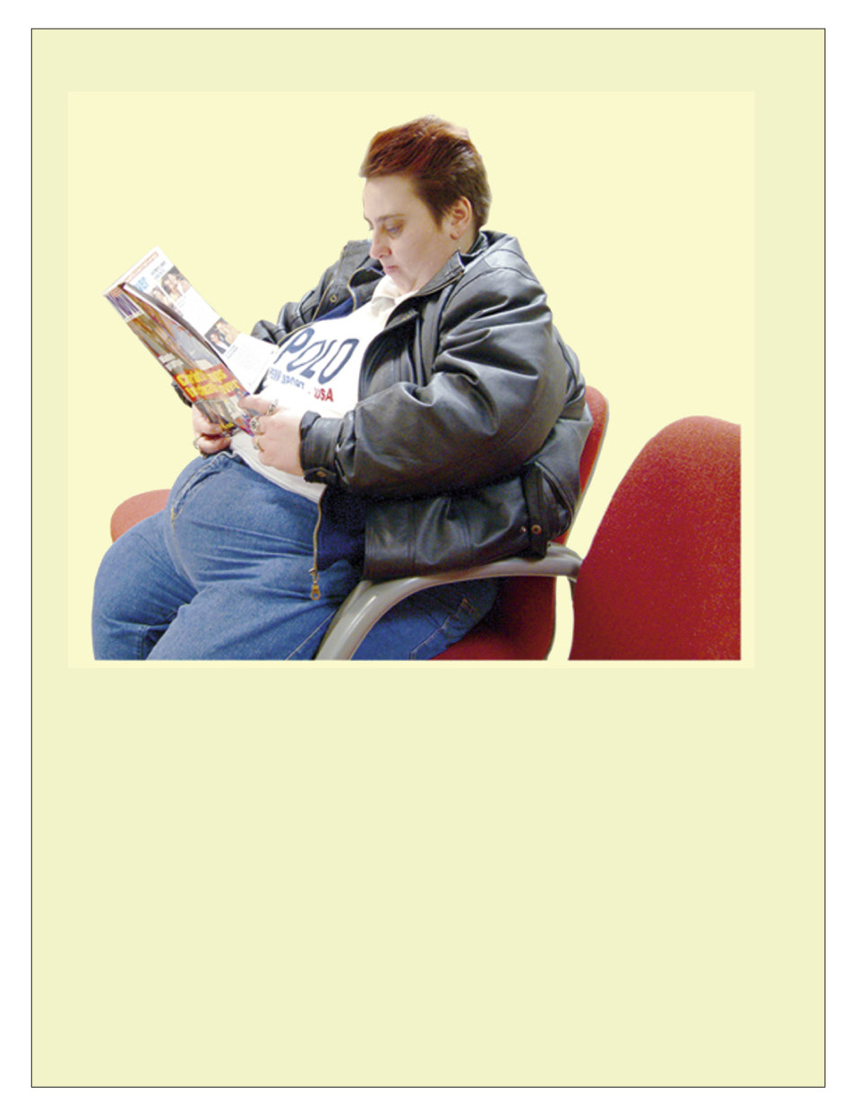

I need to wait in the waiting room. There might be other people there.

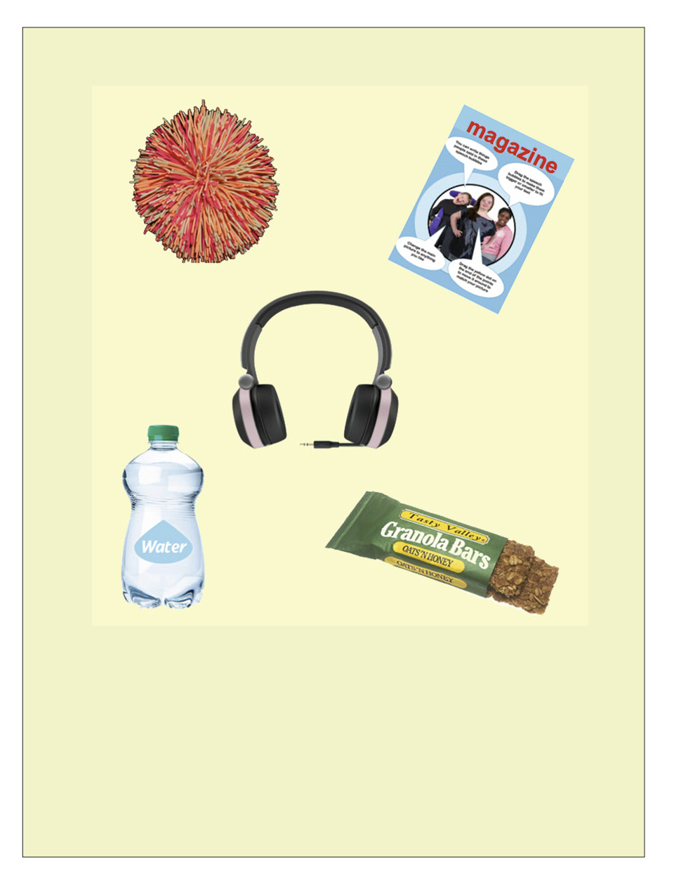

I will take something to do while
I wait and listen for my name.

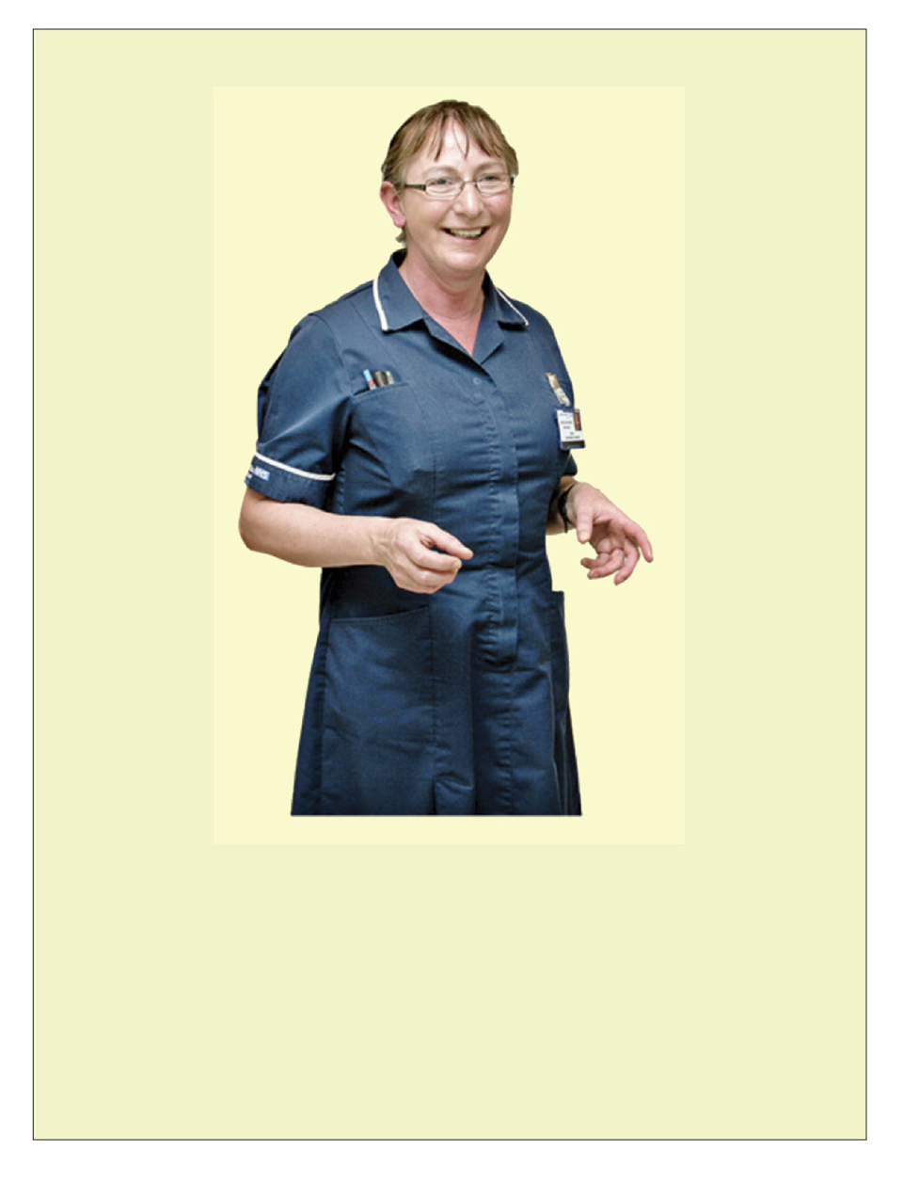

The doctor or nurse will say
‘hello’ and ask me how I am.

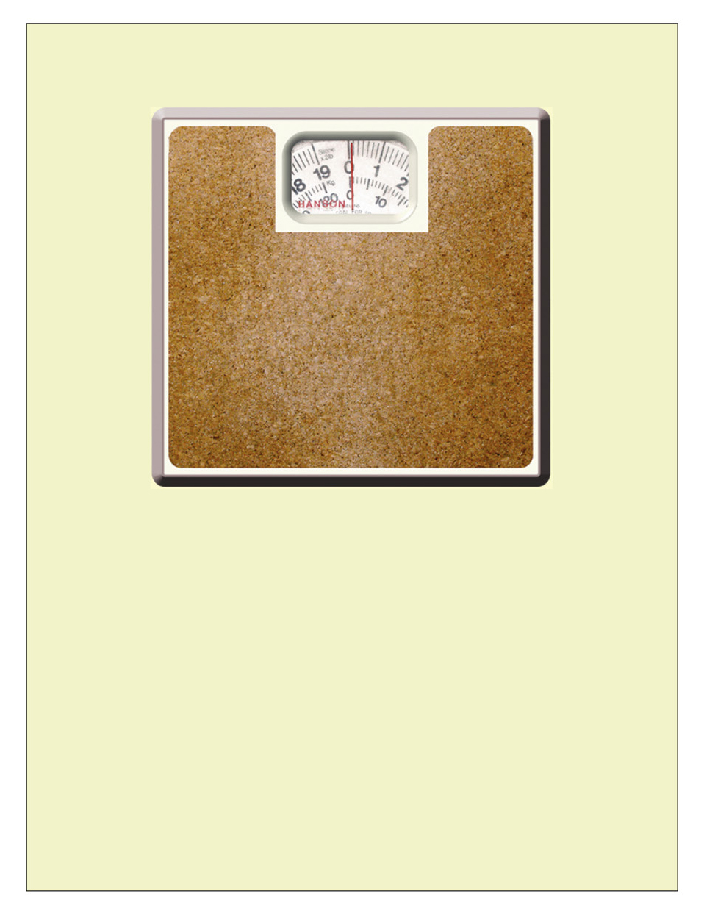

The doctor or nurse might weigh me. I will need to take my shoes off.
I will stand on the scales. It will not hurt.

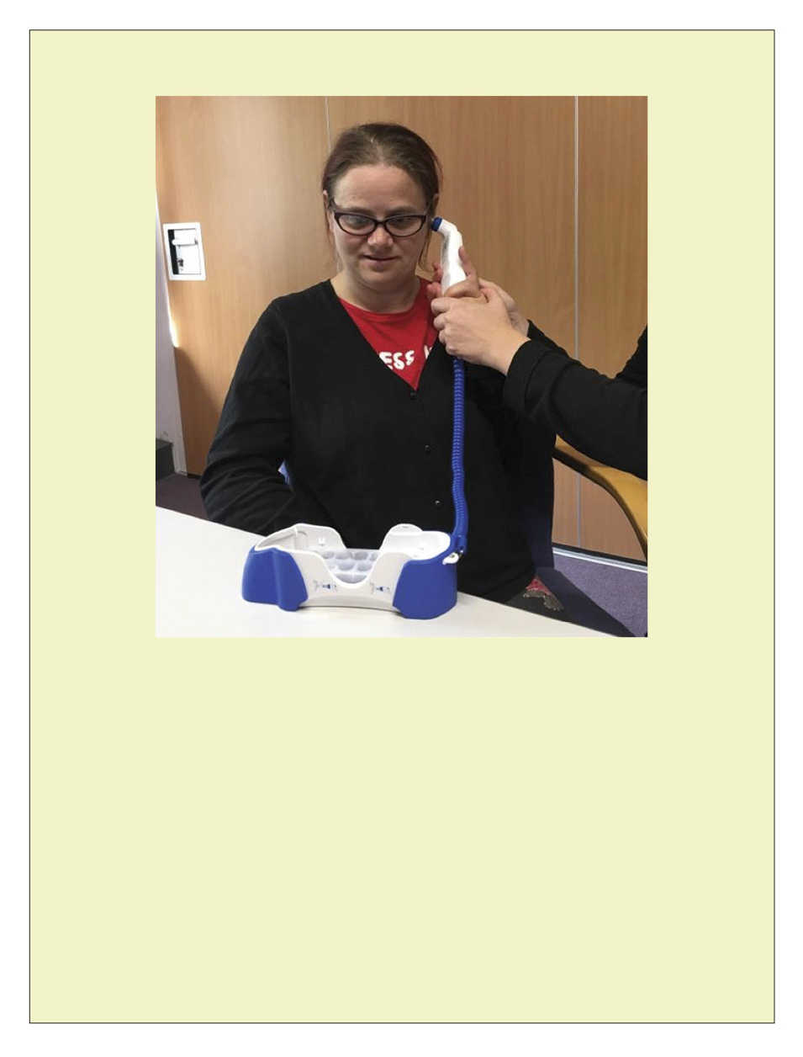

The doctor or nurse might take my temperature. They will hold a thermometer in my ear.
I will hear a beep. It will not hurt.

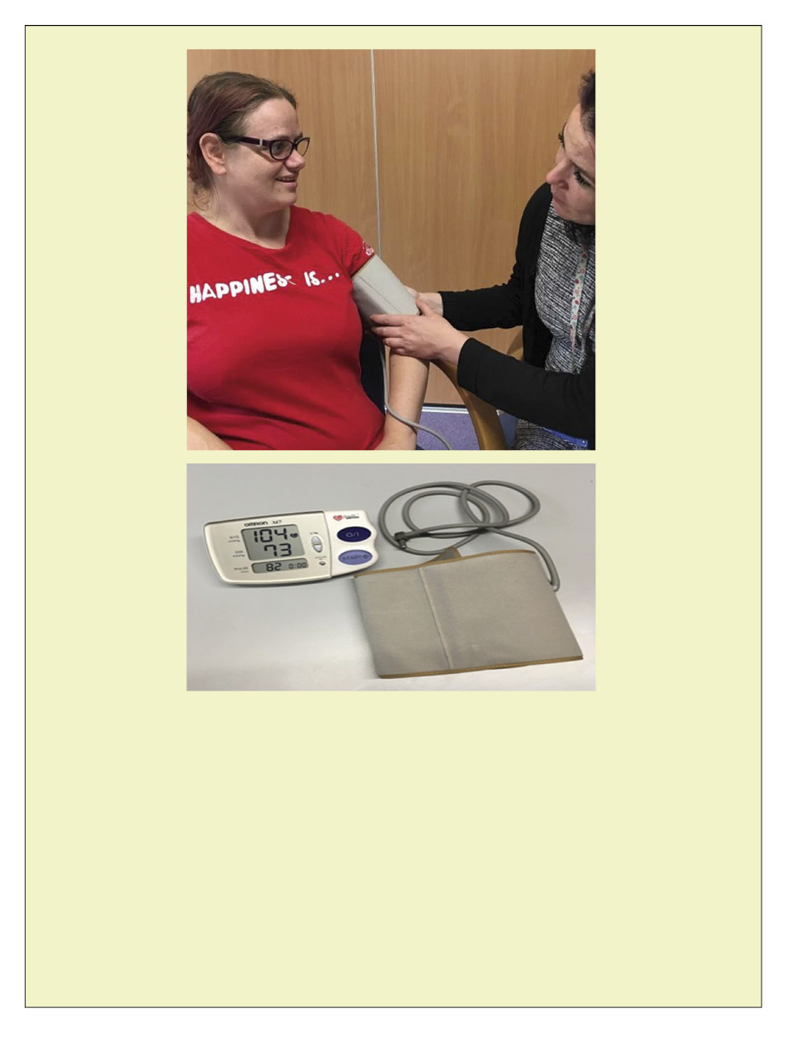

The doctor or nurse might take my blood pressure. They will put a cuff on my arm.
It will get tight and make a small noise. It will not hurt.

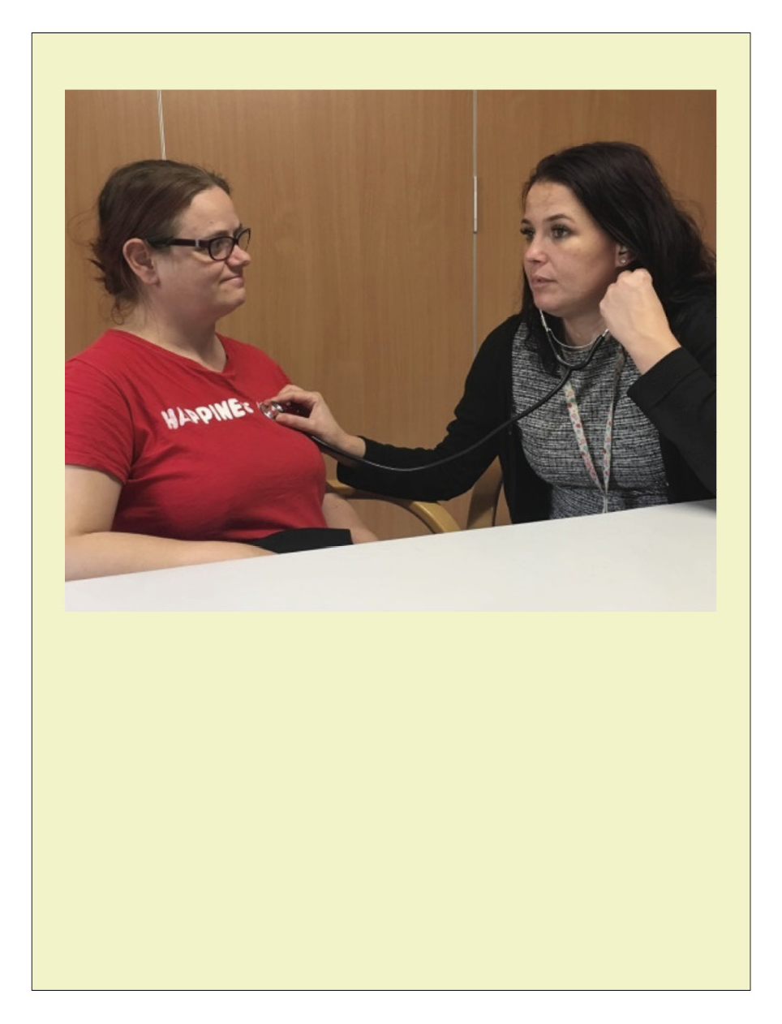

The nurse listens to the individual’s heartbeat.

The doctor or nurse may listen to your heartbeat by placing a stethoscope on your chest.

It will not hurt.

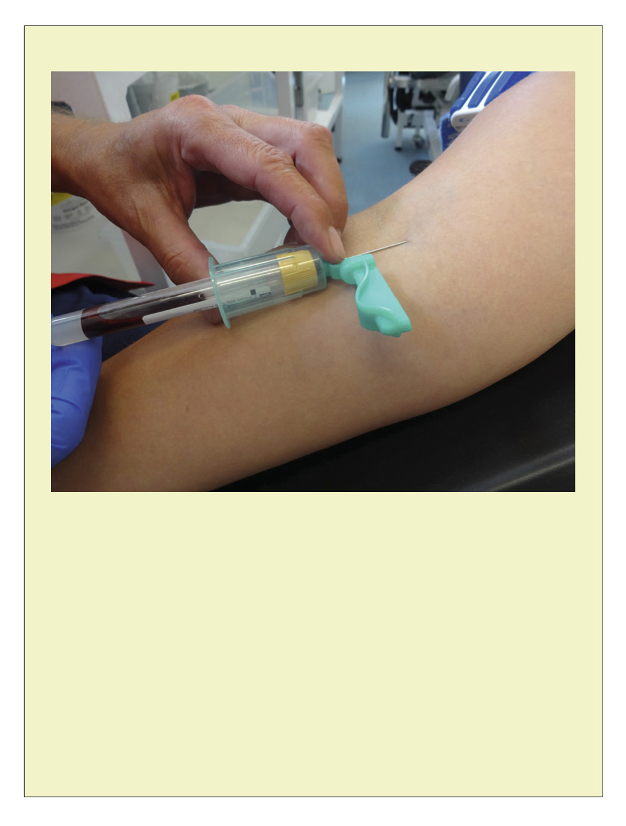

The doctor or nurse may ask you to have a blood test.

A blood test can let you know more about what is happening in your body and whether you need extra help or medication.

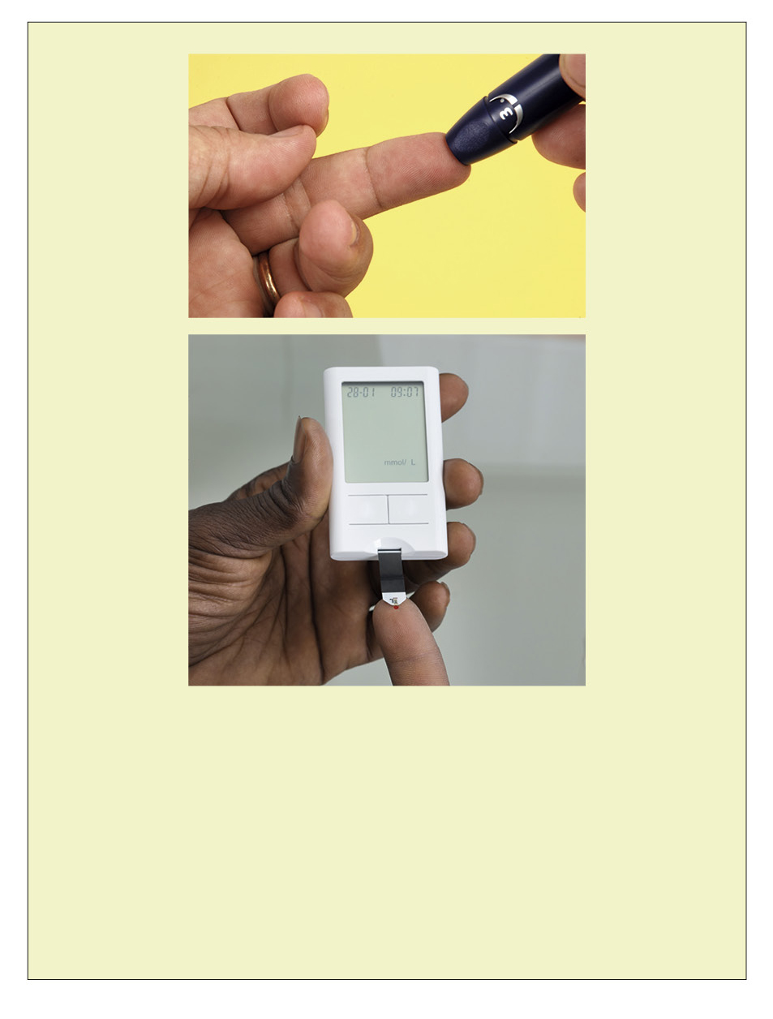

The doctor or nurse may need to do
a finger prick test to check how much sugar you have in your blood.

If you have too much sugar or not enough it can make you feel poorly.

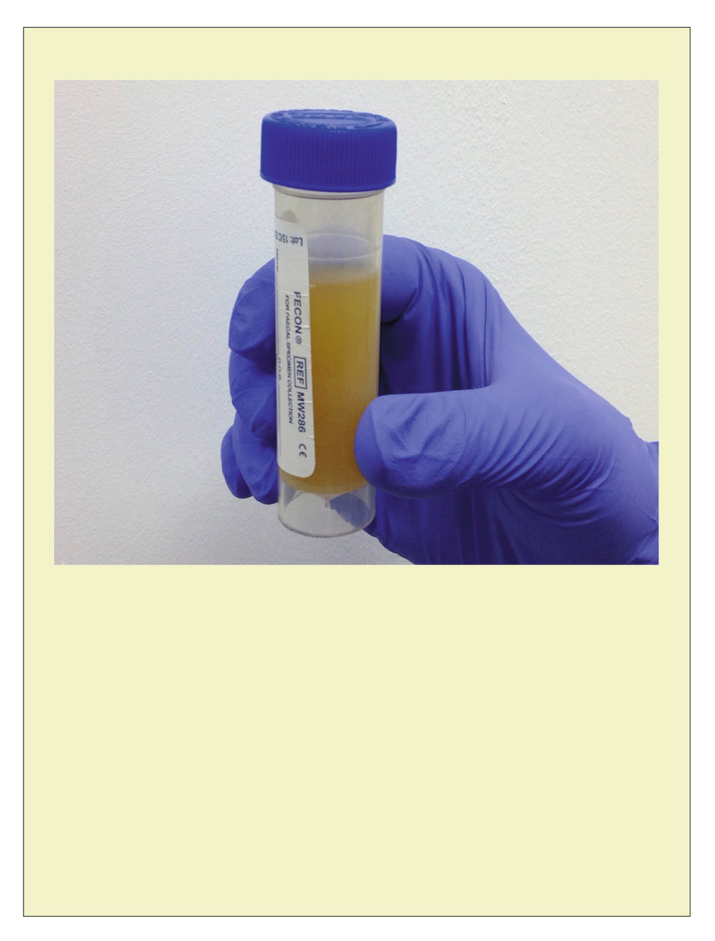

The doctor or nurse may need you to do a urine sample.

This means you will need to wee in a pot so they can test it and make sure you haven’t got an infection.

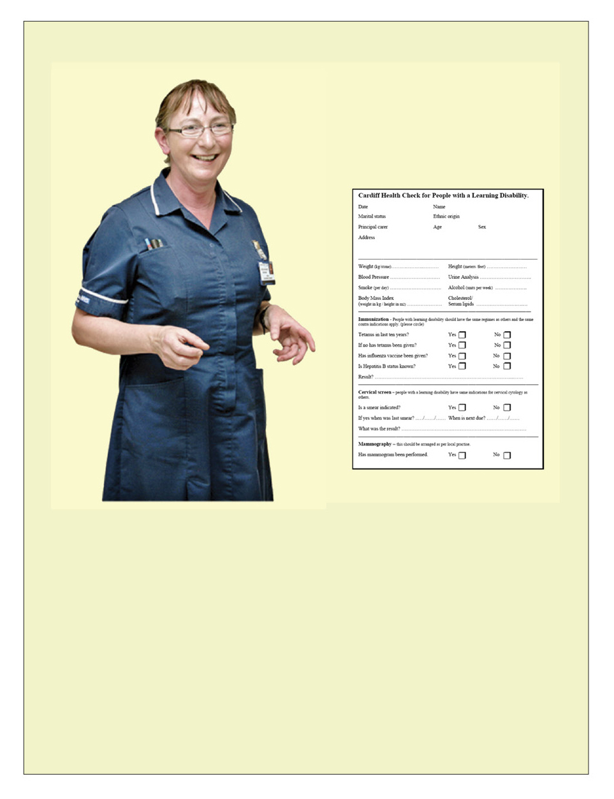

The doctor or nurse might ask some questions about my health and how I am feeling.

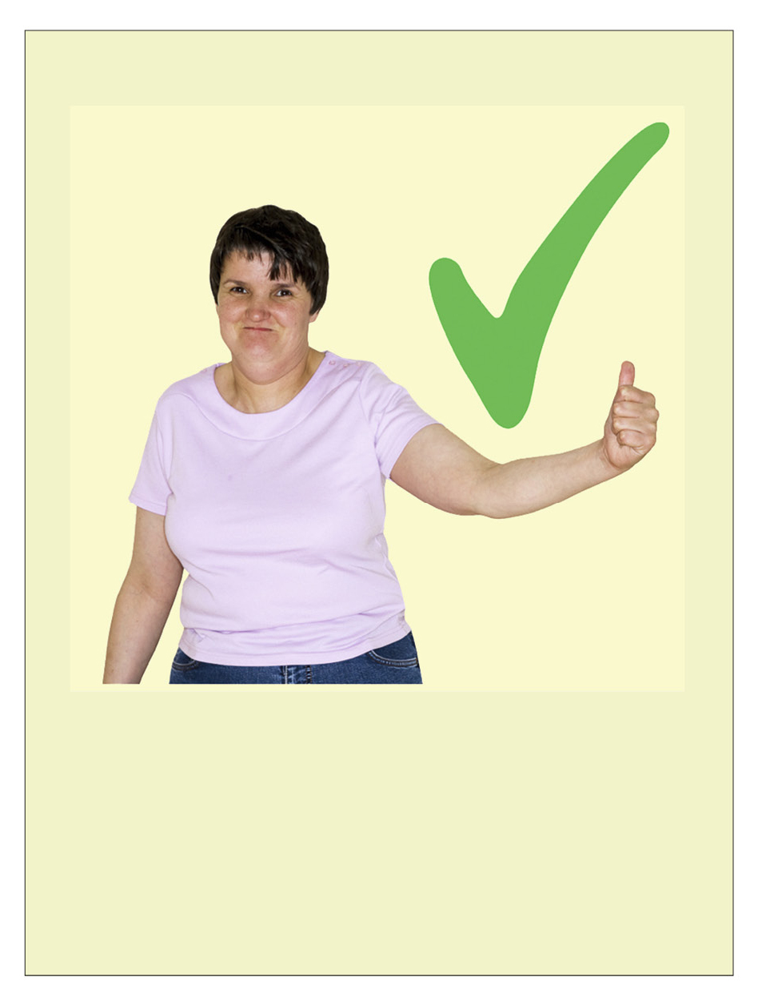

The doctor or nurse were nice.

It was good to have my health check.

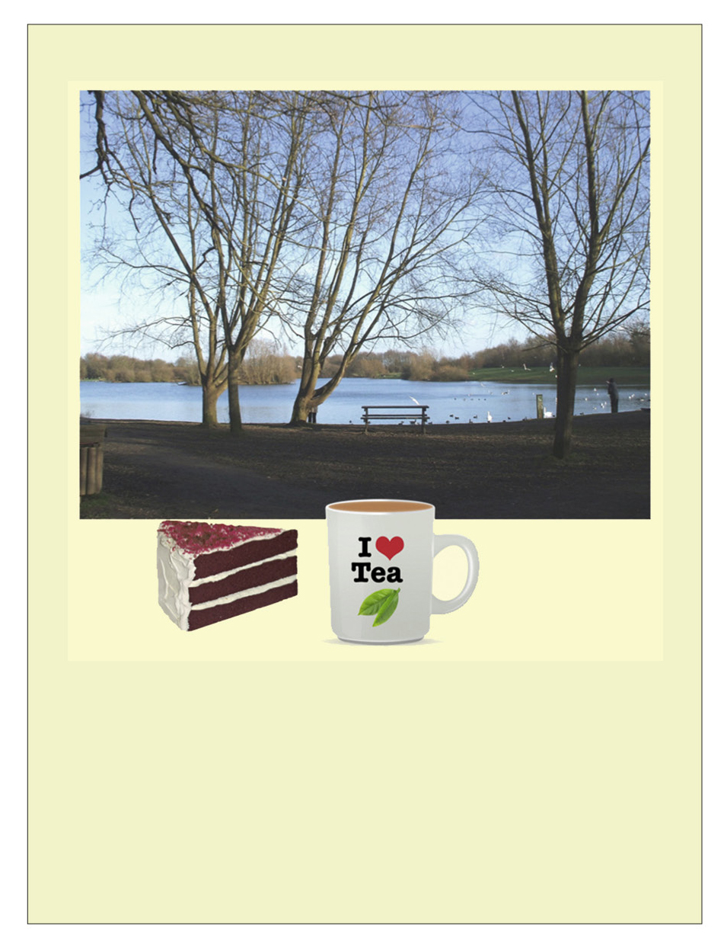

Now I have had my health check, I can do something I enjoy.

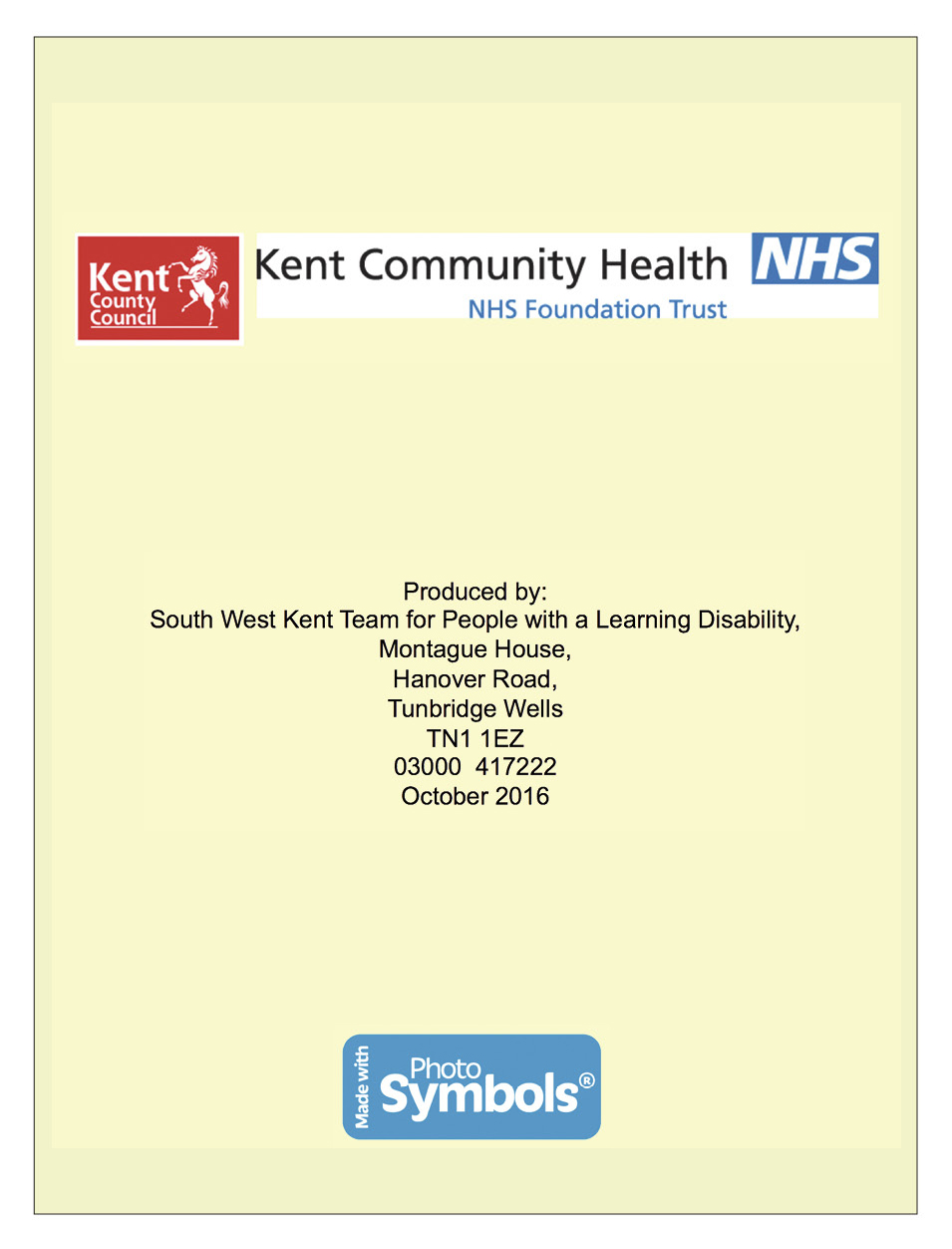

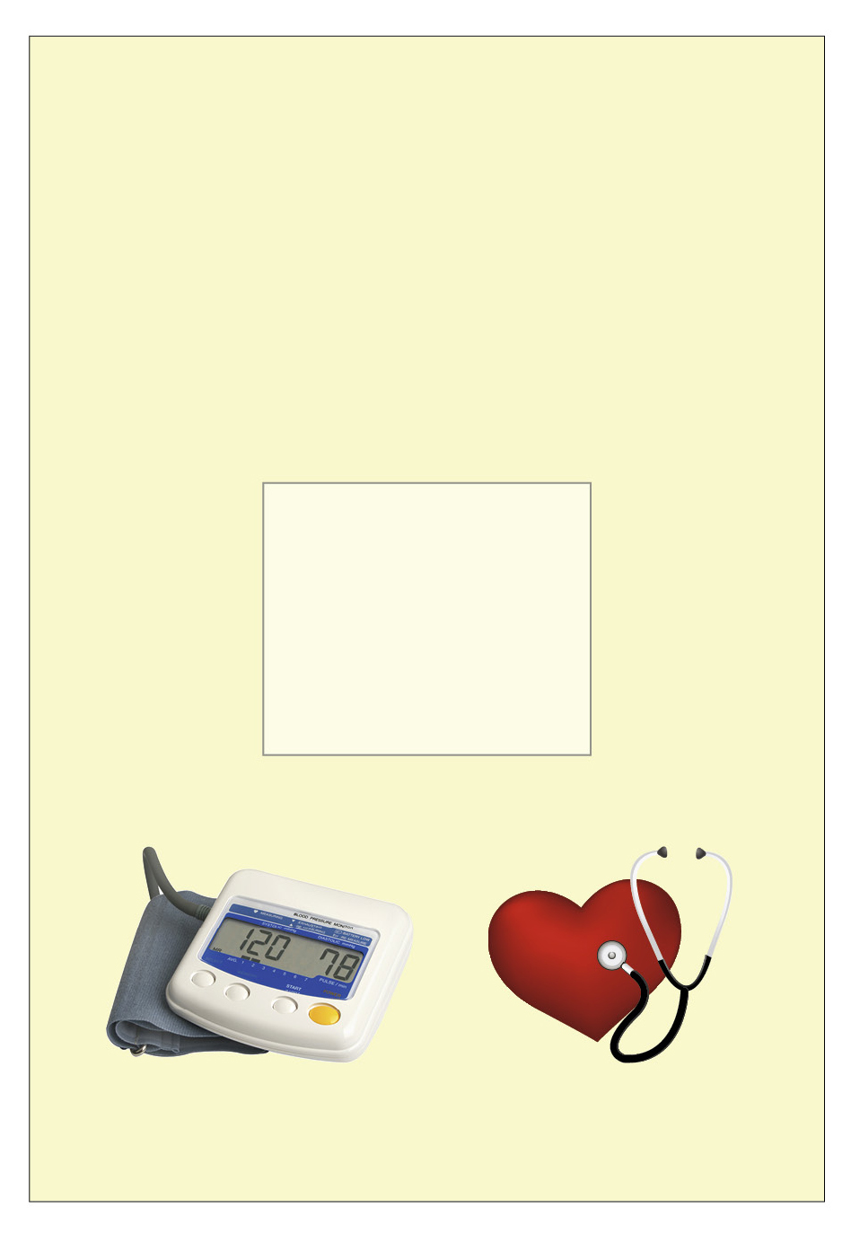

My health screening profile pack

Photograph of individual

Desensitisation profile
NAME:
Photograph
AIM: of individual
What needs to happen? | How? | When? | By who?

My health measurements | NAME: D.O.B: | Comments & contributory factors i.e. anxiety,  medication, ill health
 |  | BMI
 |  | Height
 |  | Respirations
 |  | Temperature
 |  | Pulse
 |  | Blood pressure
 |  | Weight
 |  | Date and time

Treatment log sheet
NAME: D.O.B:
Date and time | Equipment item  e.g. blood pressure cuff, tourniquet (pressure band) | How did the individual respond? i.e. smiled, frowned, touched equipment, winced | Staff comments and contributory factors

Desensitisation – monitoring chart | NAME: D.O.B: | Staff signature
 |  | Outcome
Other specific
to individual
 |  | Sensory work e.g. desensitisation to touch
 |  | Familiarisation with equipment
 |  | Health stories used
Familiarisation with environment e.g. trip to
GP/ hospital
 |  | Day and date

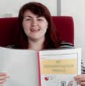

Desensitisation profile (example)
NAME: Jane Bloggs

AIM: To support Jane to have her blood pressure taken successfully with the doctor or nurse; these are steps to encourage this to happen.
What needs to happen? | How? | When? | By who?
Support Jane on trips to the surgery, to help familiarise with journey and environment. | By car – plan transport in advance, ensure transport is available on the day/time of appointment. | Once weekly for one month, then review. | Someone Jane trusts i.e. key worker.
Jane needs to feel reassured and safe. | Jane likes to take her ‘twiddle’ with her, or a snack/drink and go with someone she knows. These help her to feel more relaxed and safe.  Jane to be met at the door by the practice nurse and taken to the room with her carer. | Whenever Jane goes to medical appointments or when she visits the surgery.  For each  blood pressure appointment. | Someone she trusts.  Practice nurse.
‘Reinforcer’ to be given following any appointment or visit. | Offer Jane an activity either when out or when she returns home i.e. go for a walk, snack, coffee or something individual to her. Give verbal praise. | Whenever she is supported  to a medical appointment. | Someone who  Jane trusts.
Communicate with Jane using her preferred method of communication. | Use blood pressure cuff as object of reference.  Go through health story at each step. Use Makaton for key words. | Before, during and following appointments. | Someone who  Jane trusts.
Go through Jane’s health story with her. | Allocate one-to-one time, encourage Jane to look at the story. | Every day in the seven days prior to the appointment. | Whoever Jane is comfortable with and trusts.
Jane to become familiar with the blood pressure cuff and machine. | One-to-one time to be given  to Jane to work through blood pressure desensitisation guidelines. | Every day for five minutes. | Jane’s keyworker or identified staff she trusts.

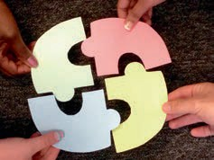

Name of service: Carer name:
Carer designation:

Name of person being supported:

I am aware of and understand the importance of the following:

1. What health screening the person I am supporting needs and why.

2. What the potential barriers could be for them and how we may be able to overcome these.

3. That I have a very important role in supporting this person with health screening familiarisation and desensitisation.

4. That I need to support this person with the ‘health screening homework’, in between clinical sessions/appointments.

5. That I need to ensure others are supporting them with this when I am not available.

6. That I need to work together with the person I am supporting, their GP and other clinicians involved, so that their health needs can be met.

Signature of carer:

Handout 2.20: What can go wrong: scenario 1

Harry is 24-year-old man with moderate learning disabilities. He is able to communicate using some keywords but can become very frustrated as he often struggles to make his needs known. Harry can become very distressed at these times and can be challenging towards the environment and others.

During the screening process, Harry was identified by his GP as needing a blood test, but it was suggested he had a ‘needle phobia’.

The barriers to health screening identified included Harry having negative experiences when having blood tests as a child, including being ‘held down’ when having blood taken.

Because of the past negative experiences the initial five desensitisation sessions consisted of building a rapport with Harry, gaining his trust and rewarding him for coming to the clinic.

This was built up over the weeks and health screening equipment was introduced, such as BP cuff and machine, thermometer and stethoscope. Building Harry’s confidence with the health screening equipment and process and ensuring he was aware he was in control of what was happening was essential. This process took several months and we purposely did not introduce blood test desensitisation at this time.

Despite the staff training and education provided, Harry was supported by various members of staff to sessions. There was high staff turnover in this particular house and it was apparent that a certain member of staff did not have a positive attitude towards the desensitisation work, despite much time spent discussing this with him.

We had reached the stage with Harry where he had had his blood pressure taken several weeks in a row and was comfortable with the thermometer and stethoscope. He was generally relaxed during clinics and following a very positive session we were looking at starting blood test desensitisation within the next few sessions.

Harry was supported to the next session by the member of staff mentioned and we commenced the session as he was used to, by meeting and greeting and going through the equipment he was now familiar and confident with. We praised Harry and recapped all the positive things he had achieved so far.

At this point the member of staff became cross and said, ‘This is ridiculous. You’re just avoiding what he’s really here for; where are the needles? Get the needles out and show him, then you’ll see what the problems are’. At this point Harry became very upset rocking and saying repetitive phrases. He looked extremely anxious and started pushing away the equipment. We reassured Harry that we were not going to do anything he did not want to but he was distressed and obviously wanted to leave.

This inappropriate dialogue and behaviour from the member of staff set Harry back months. At the next clinic he was so anxious we had to go right back to the beginning with him and just build up the rapport and confidence again. It took weeks to take his blood pressure and several months in total before we could commence blood desensitisation work with him.

Handout 2.21: What can go wrong: scenario 2

Mavis is a 50-year-old lady with moderate learning disabilities. She has a severe communication disorder, epilepsy and diabetes.

During the screening stage it was established that Mavis had very negative past experiences with health screening, including being held down when requiring medical intervention and many emergency visits to A&E following going into an epileptic fit or due to her diabetes.

Mavis responded well to one-to-one intense desensitisation with the learning disability nurses and attending the desensitisation clinic. Over time she was able to have her blood pressure and temperature taken, weight and height measured, and was able to wear the tourniquet for two minutes.

Her confidence grew over the months and after intensive one-to-one support from learning disability nurses and good support from staff in between clinics, she was able to have regular blood glucose monitoring and successfully had a blood test.

Learning disability nurses were phased out at this point, handing over to the staff team supporting Mavis to continue with weekly desensitisation/familiarity with equipment and regular visits to the GP. Unfortunately this did not happen and the major achievements made by Mavis with health screening were not included as part of her care plan or weekly routine.

As a consequence, when Mavis had difficulties with her diabetes and an increase in her seizure frequency months later, she had regressed regarding anxiety around health screening, resulting in staff being unable to support her to necessary appointments.

Consequently nursing received another referral for desensitisation work.

Not continuing to include health desensitisation as part of her weekly plan and spending just 5/10 minutes per week on this meant Mavis had to go through the whole process again, wasting months and months of effort and work.

It also meant that she was not able to undertake essential health screening required due to the significant changes in her health needs which had a serious impact on both her health and quality of life.

Step 1: individual to wear the tourniquet daily. Start by wearing it for one minute then increase gradually, up to five minutes.

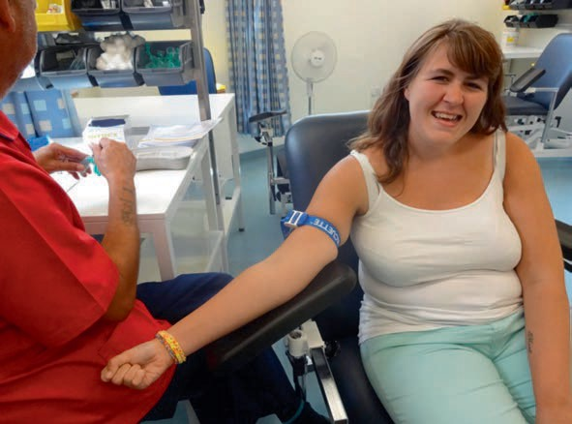

Step 2: individual to be given a syringe to hold and familiarise with each day for a few minutes.

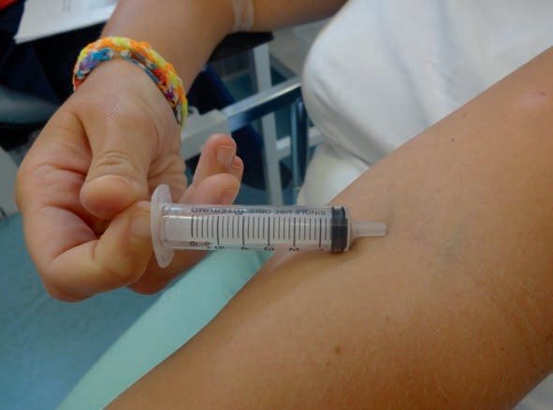

Step 3: individual to wear the tourniquet and hold
the syringe at the same time for up to a maximum of five minutes.

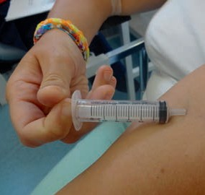
Step 4: individual to wear the tourniquet and hold the syringe. Staff to use an alcohol wipe on the inside of the elbow.

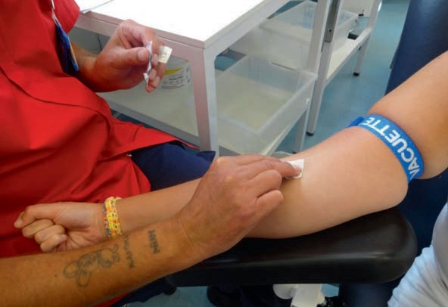

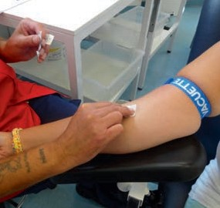
Step 5: individual to wear the tourniquet, staff to apply alcohol wipe. Staff to hold the syringe, and place it where the elbow has been cleaned.

NURSE ONLY INTERVENTION

Step 6: individual to wear the tourniquet, alcohol wipe to be applied and nurse to place syringe with needle attached to the inside of the elbow.

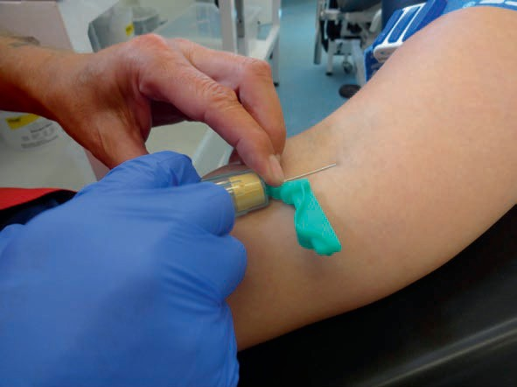

NURSE ONLY INTERVENTION

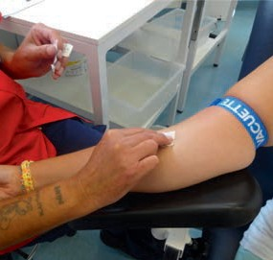
Step 7: individual to wear the tourniquet, alcohol wipe to be applied. Nurse to place syringe with needle attached to the inside of the elbow. Individual to be shown separate syringe with fake blood in it.

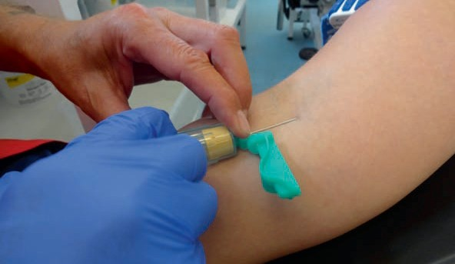

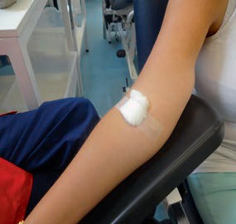

NURSE ONLY INTERVENTION

Step 8: to follow step 7. Individual to be shown a syringe and needle with blood in it. Cotton wool ball to be placed on the inside of his elbow and pressure applied for several seconds.

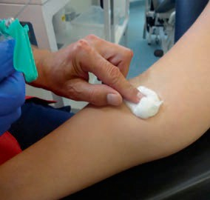

NURSE ONLY INTERVENTION

Step 9: to follow steps 7 and 8. Cotton wool ball to be placed on the inside of his elbow and pressure applied. Small round plaster to be applied to the area.

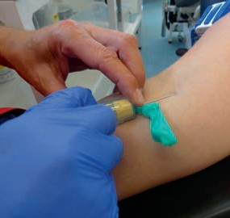

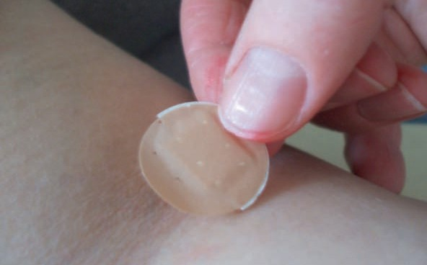

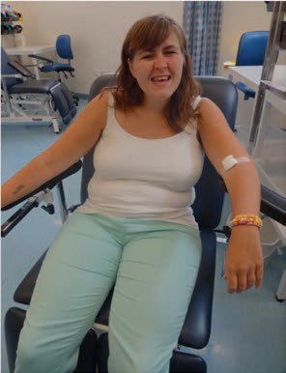

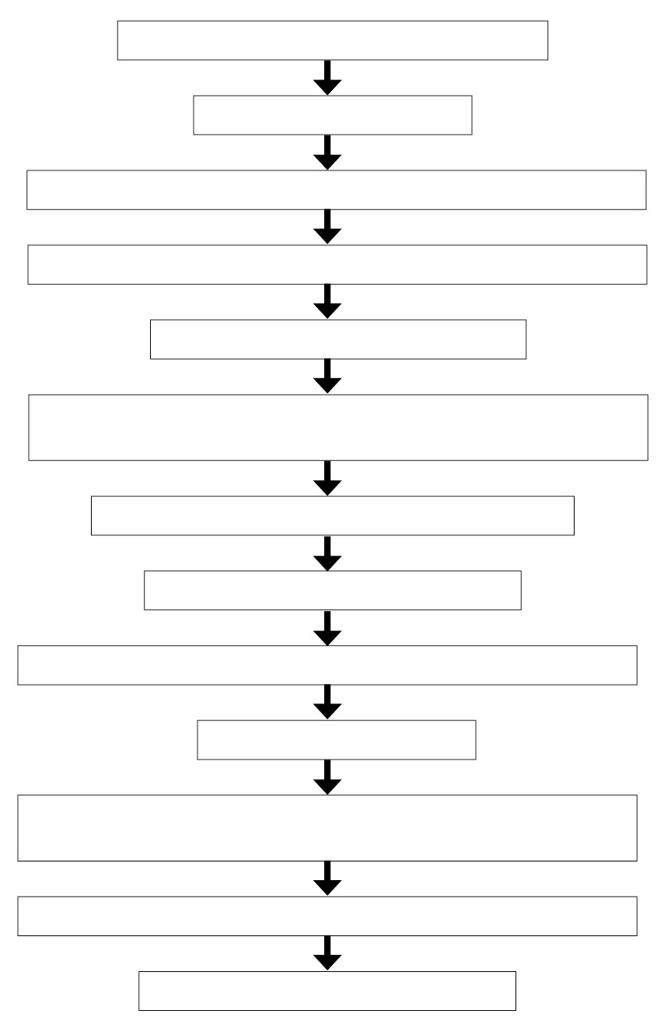

Screening process

Assess capacity

Complete barriers to health screening checklist

Identify reasonable adjustments required

Person-centred/creative techniques

Commitment tool to be completed with medical/health professionals, carers and families

Complete desensitisation profile

Health facilitation stories

Identify specific desensitisation programmes

Prepare environment

Implement desensitisation – incorporate into weekly schedule and carry out homework

Complete recording and monitoring charts

Feedback to GP/practice nurse

